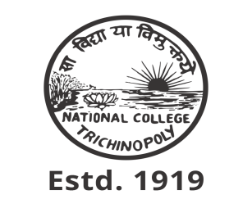
NATIONAL COLLEGE (AUTONOMOUS), TRICHY.
DEPARTMENT OF B.VOC
(INFORMATION COMMUNICATION TECHNOLOGY)
SEMINAR
The B.Voc (Information Communication Technology) Department at National College (Autonomous), Trichy, held a seminar on "Data Analytics Tools" on Friday, December 15, 2023, at 4:10 PM in the College Library AV Hall. The event was presided over by Dr. K. Kumar, with a welcome address by student M. Swathi.
The seminar featured Dr. G. Arockia Sahaya Sheela, Head of the Department of Data Science at Holy Cross College (Autonomous), Trichy, as the distinguished speaker. Dr. Sheela delivered an engaging presentation on the nature of data, focusing on its use in social networking sites, data handling techniques, and the growing significance of data in today's technological landscape.
In appreciation of her contribution, Dr. G. Arockia Sahaya Sheela was honored with a memento by Prof. N. Parthasarathy, Head of the B.Voc (ICT) Department. The seminar concluded with a vote of thanks from student A. Abdul Sameer, marking the end of a successful and informative event.
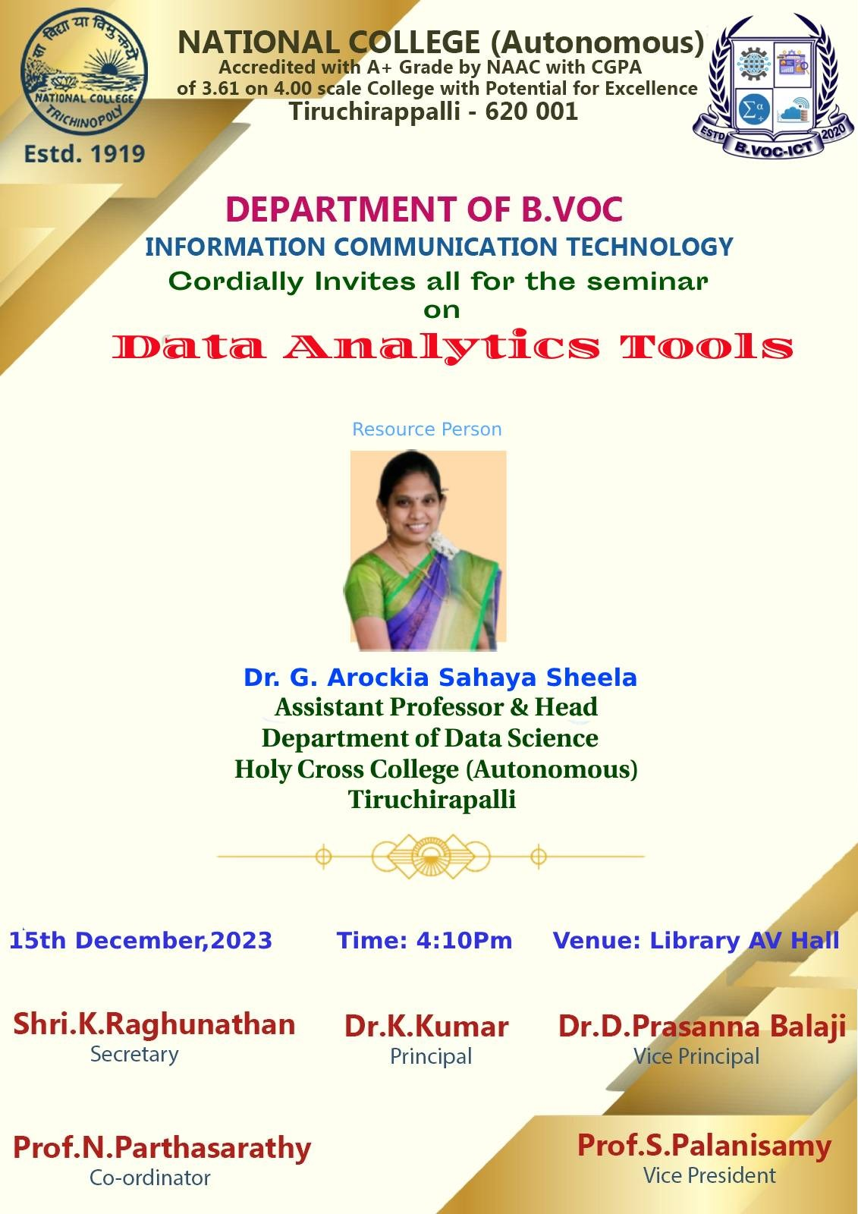

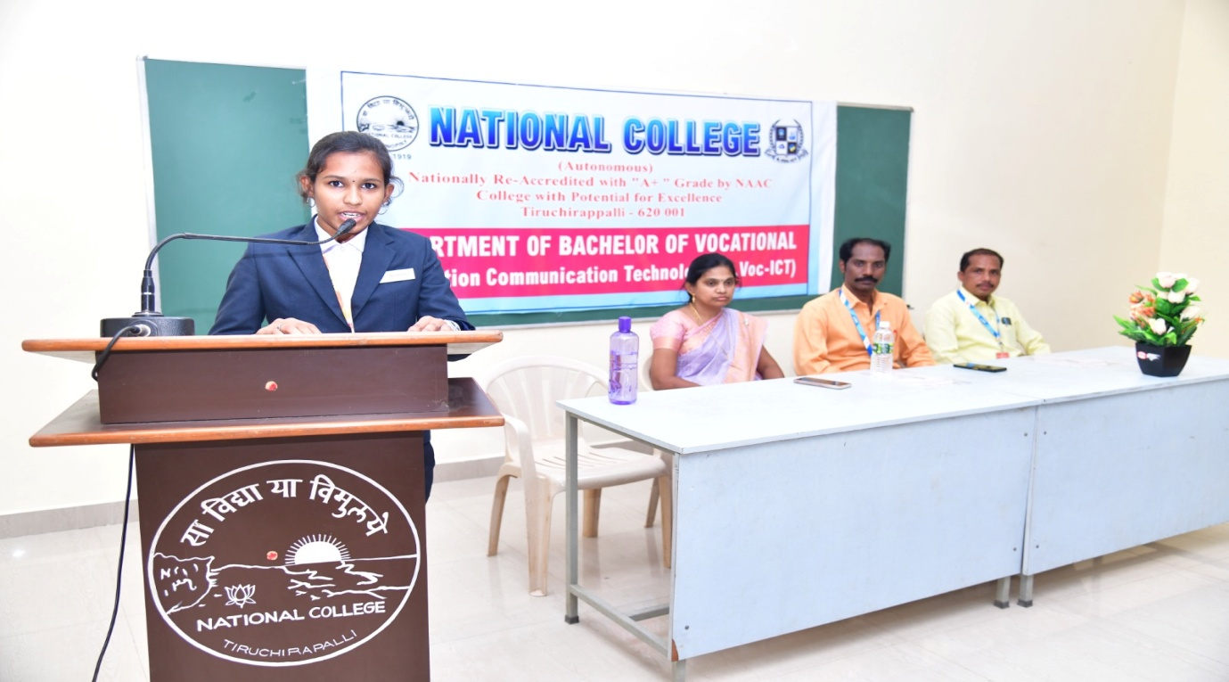
PHOTO DETAILS:
Crawl from left
- Student's President, M. Swathi (III B.VOC)
- Dr. G. Arockia Sahaya Sheela, Head, Department of Data Science, Holy Cross College (Autonomous), Trichy.
- Prof. N. Parthasarathy, Coordinator, B.VOC (ICT), National College, Trichy.
- Prof. S. Palanisamy, Vice President, B.VOC (ICT), National College, Trichy.

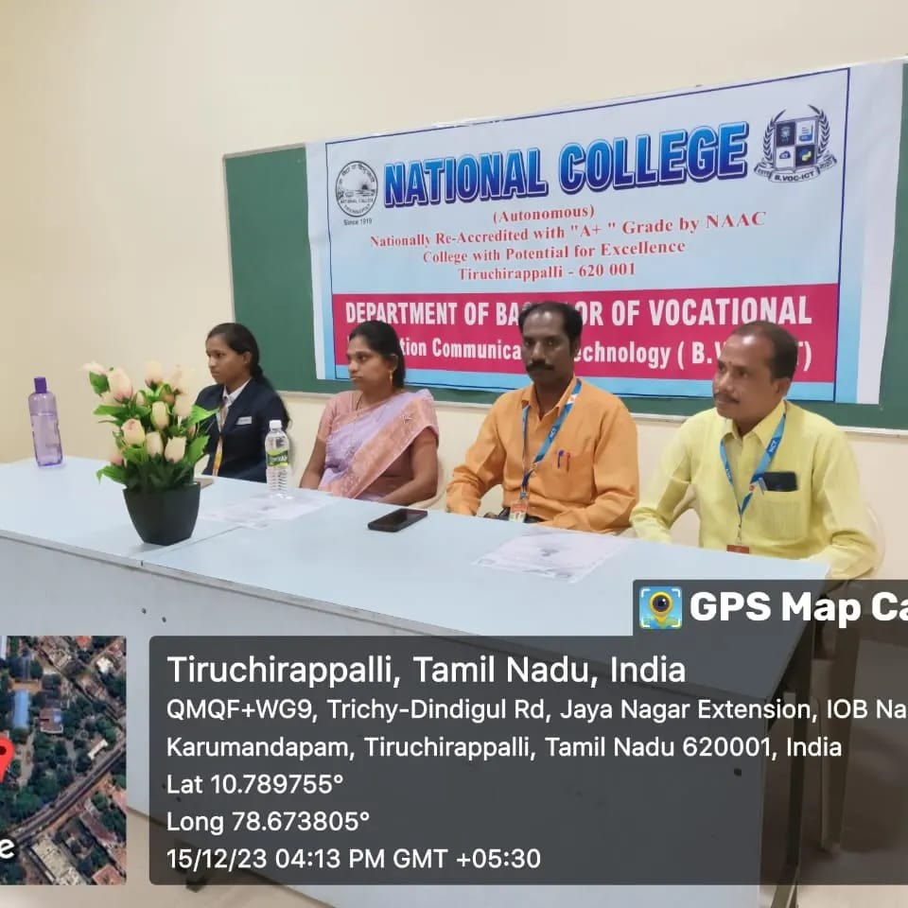

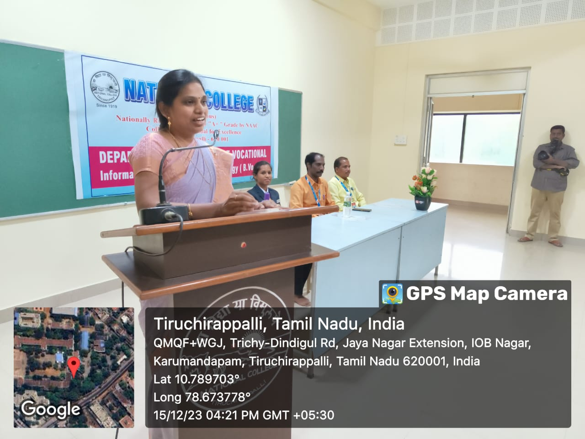

NATIONAL COLLEGE (AUTONOMOUS), TRICHY.
DEPARTMENT OF B.VOC
(INFORMATION COMMUNICATION TECHNOLOGY)
MoU
On Friday, December 22, 2023, at 4 PM, a significant event was held in the Meeting Hall of National College (Autonomous), Trichy. The B.Voc (Information Communication Technology) Department, recognized for its excellence, signed a Memorandum of Understanding (MoU) with T4TEQ Software Solutions.
The ceremony was presided over by Principal Dr. K. Kumar, with the esteemed presence of Vice Principal Dr. D. Prasanna Balaji, and coordinated by Prof. N. Parthasarathy, Head of the B.Voc (ICT) Department. The event commenced with a welcome address by student M. Swathi.
Mr. Ismail, Managing Director of T4TEQ Software Solutions, and Ms. Bhuvaneshwari, a software developer at T4TEQ, attended the event. They expressed high regard for the college and the B.Voc (ICT) Department during the signing of the MoU.
In recognition of their support, the principal of the college honored the special guests with gold shawls and mementos. The ceremony concluded with a vote of thanks delivered by student A. Abdul Sameer.
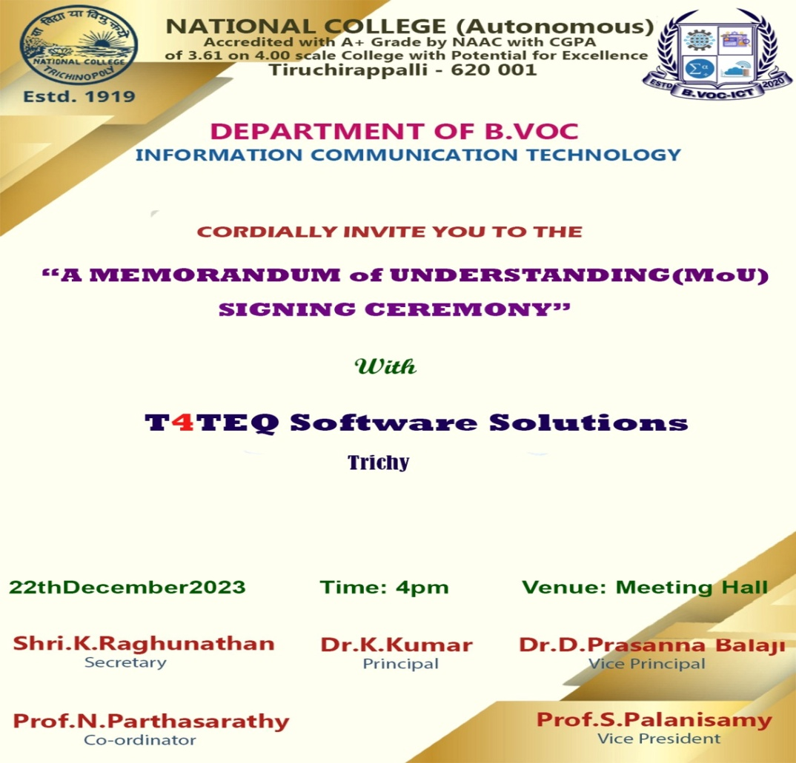
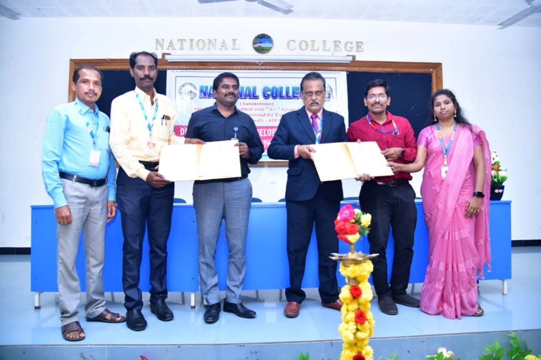

PHOTO DETAILS:
Crawl from left

1. Prof. S. Palanisamy, Vice President, B.VOC (ICT), National College, Trichy.
- Prof. N. Parthasarathy Coordinator B.VOC (ICT), National College, Trichy.
- Vice Principal, Dr. Prasanna Balaji National College, Trichy.
- Principal, Dr. K. Kumar National College, Trichy.
- Managing Director, Mr. Ishmail T4TEQ, Trichy.
- Software Developer, Ms. Bhuvaneshwari, T4TEQ, Trichy.

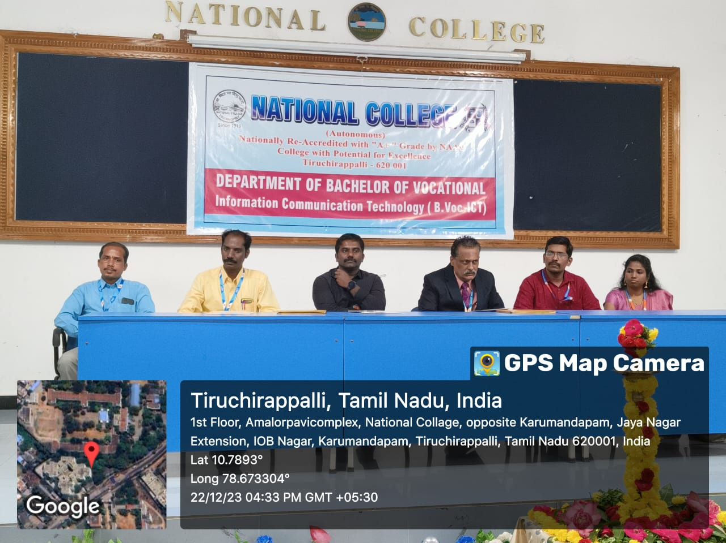
NATIONAL COLLEGE (AUTONOMOUS), TRICHY.
DEPARTMENT OF B.VOC
(INFORMATION COMMUNICATION TECHNOLOGY)
MoU
On Thursday, December 28, 2023, at 4 PM, a Memorandum of Understanding (MoU) was signed between the B.Voc (Information Communication Technology) Department of National College (Autonomous), Trichy, and LiveWire Software Technology. The event took place in the College Meeting Hall.
The ceremony was presided over by Principal Dr. K. Kumar, with the coordination of B.Voc (ICT) Department, Head, N. Parthasarathy and Vice-President S. Palanisamy. The program was anchored by student Ayyappan, and student M. Swathi delivered the welcome address.
Mr. Satish Kumar, Managing Director of LiveWire Software Technology, and Gnanavel, a software developer at the company, attended the event. They highlighted the importance of emerging software technologies and the need for their development before signing the agreement.
The principal of the college honored the special guests with gold shawls and mementos. The event concluded with a vote of thanks from student A. Abdul Sameer.
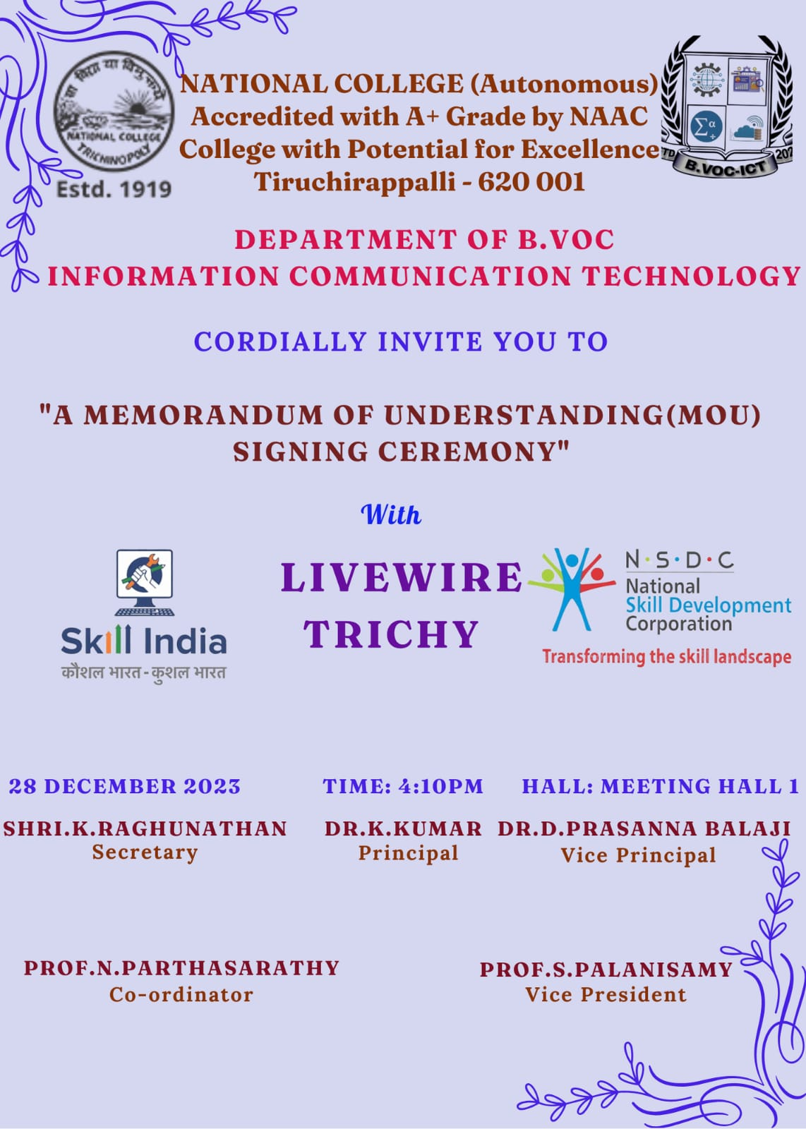

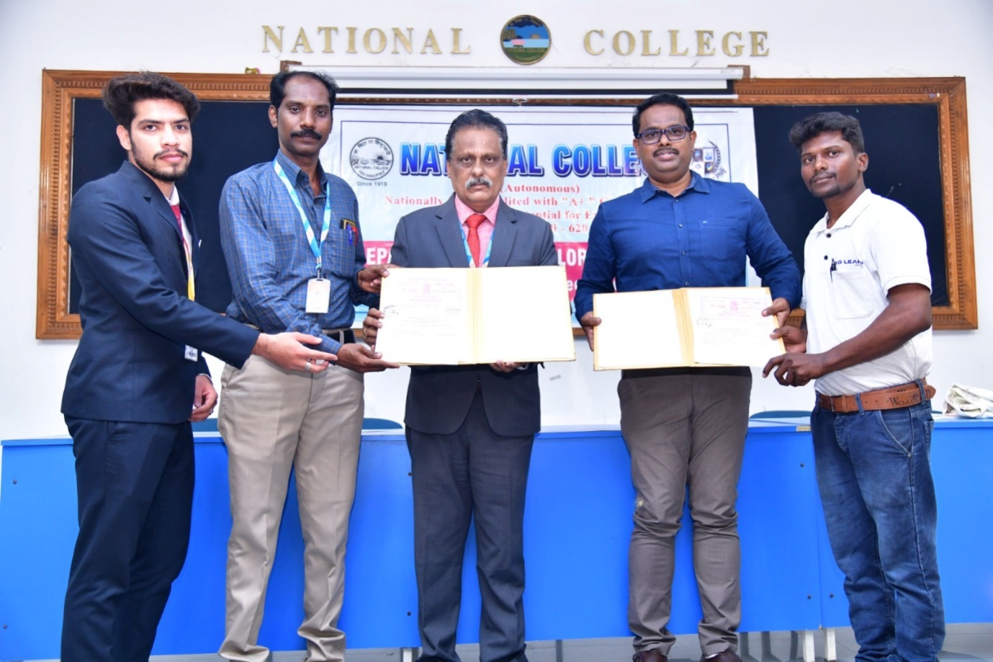
PHOTO DETAILS:
Crawl from left
- A. Abdul Sameer, Student’s President, B.VOC (ICT), National College, Trichy.
- Prof. N. Parthasarathy, Head, B.VOC. (ICT), National College, Trichy.
- Principal, Dr. K. Kumar, National College, Trichy.
- Mr. Satishkumar, Managing Director, LiveWire, Trichy.
- Mr. Gnanavel, software developer, LiveWire, Trichy.

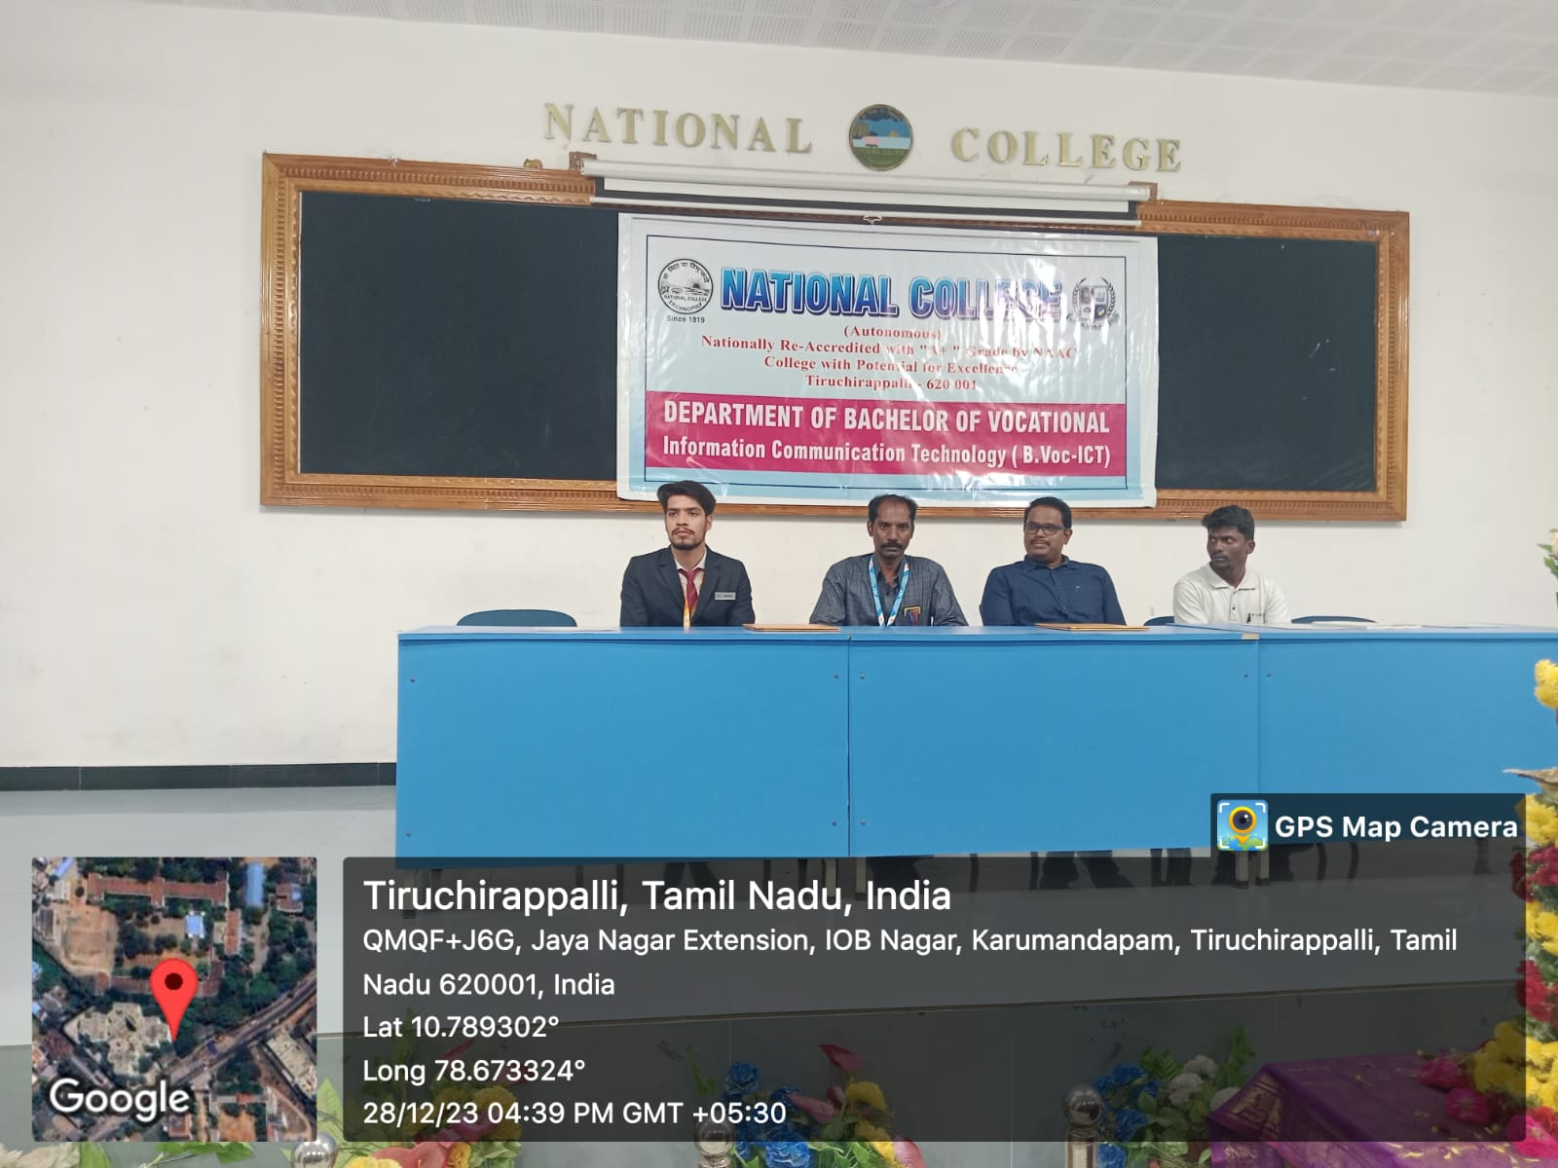
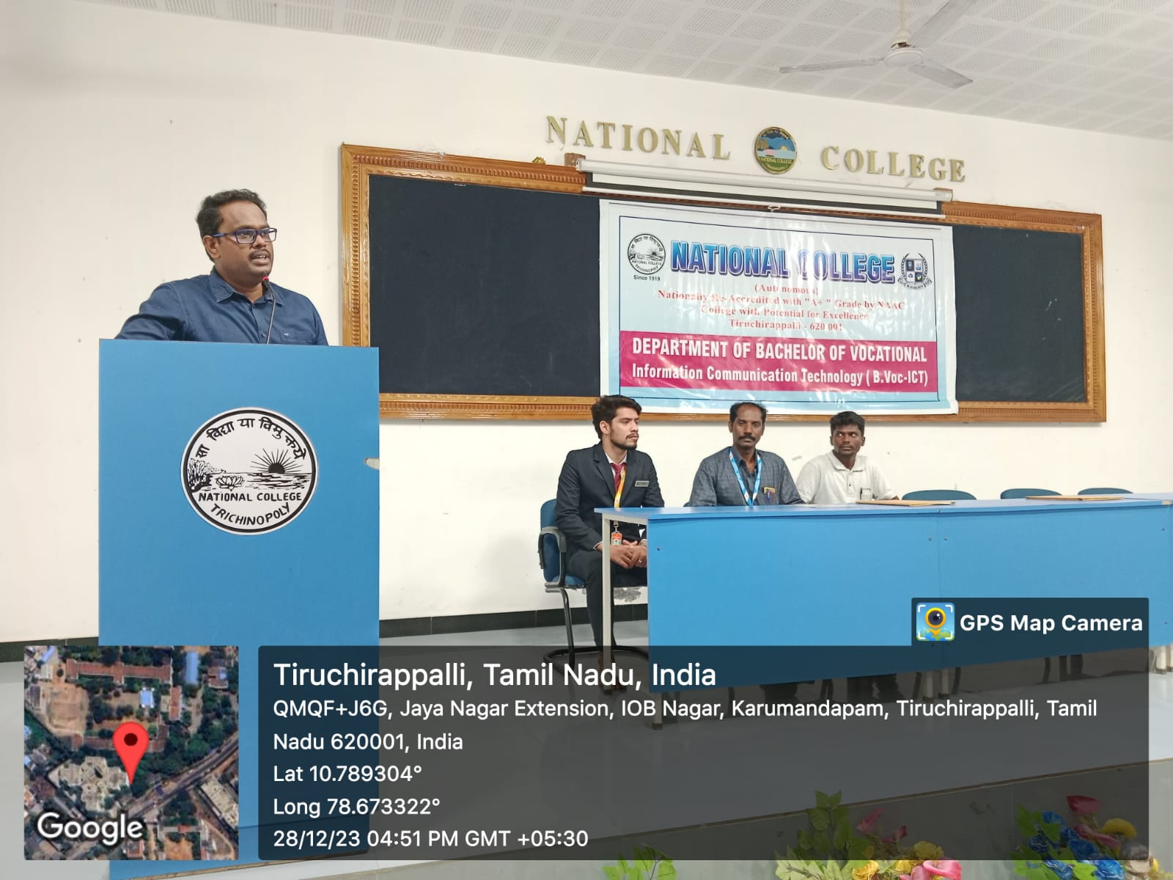

NATIONAL COLLEGE (AUTONOMOUS), TRICHY.
DEPARTMENT OF B.VOC
(INFORMATION COMMUNICATION TECHNOLOGY)
WORKSHOP
Day 1:
A workshop on "FULL STACK DEVELOPMENT" was held in Computer Lab 1, National College, organized by the department B.VOC (ICT) in collaboration with LiveWire Software Company Trichy on Wednesday and Thursday (10/1/24 and 11/1/2024). Principal Dr. K. Kumar delivered the presidential address, and Vice Principal Dr. Prasanna Balaji inaugurated the workshop. The student, Ms. M. Swathi, delivered the welcome address.
The workshop started off with the active participation of the students in the coding competition organized by LiveWire software company, Trichy. The Managing director, Mr. M. Satish Kumar, and a special guest presented certificates and mementos to the students who won the Coding Program competition. LiveWire Software Engineer, Mr. Rajeev Ranjan, explained the concepts of full-stack development and Angular software. He provided interactive training on how to create a web page.
Day 2
Mr. N. Parthasarathy, Head, Department of B.VOC (ICT), delivered a brief introduction for the speaker of the day, Ms. V. Kamachi. Software Engineer, Ms. V. Kamachi, practically delivered sessions on CSS and JavaScript. She trained students through practical sessions. IQAC Coordinator and Vice Principal, Dr. Bennett, a special guest of the day, spoke to the students about the development and job opportunities of B.VOC (ICT). The software engineers were honored with Mementoes, who well-trained the students in the workshop.
Vice Principal, Dr. Bennett, honored LIVE WIRE Software Company Managing Director, Mr. K. Sathish Kumar, with a memento. Certificates are awarded to the students who participated in the two-day interactive sessions of the workshop. The workshop ended with the blessings of God and the secretary. A vote of thanks was delivered by the student, Mr. M. Ayyappan (I B.Voc (ICT)).

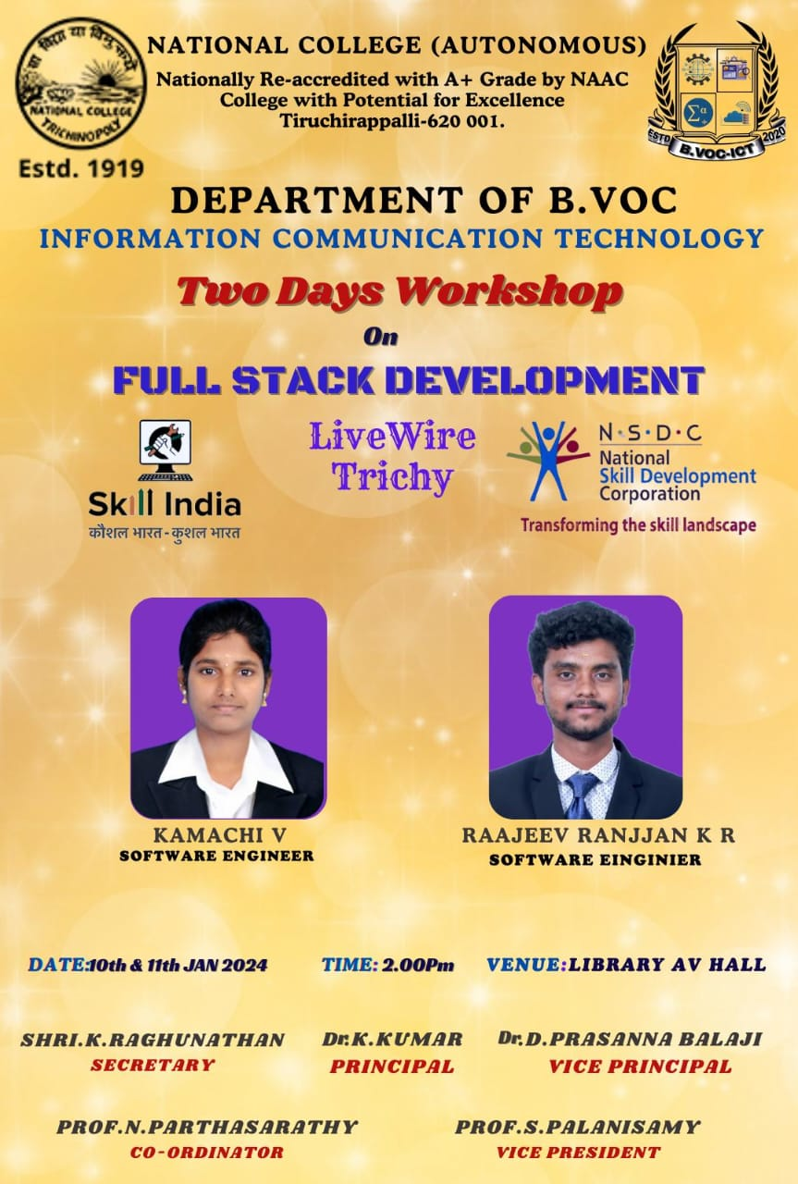

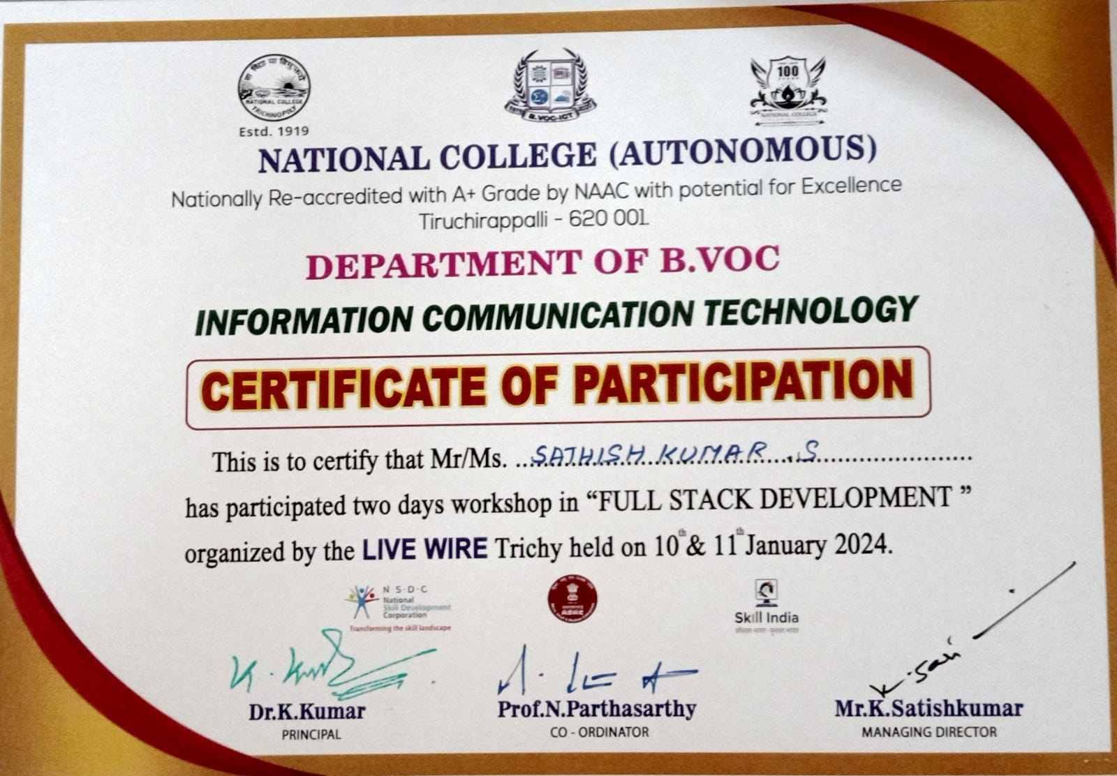

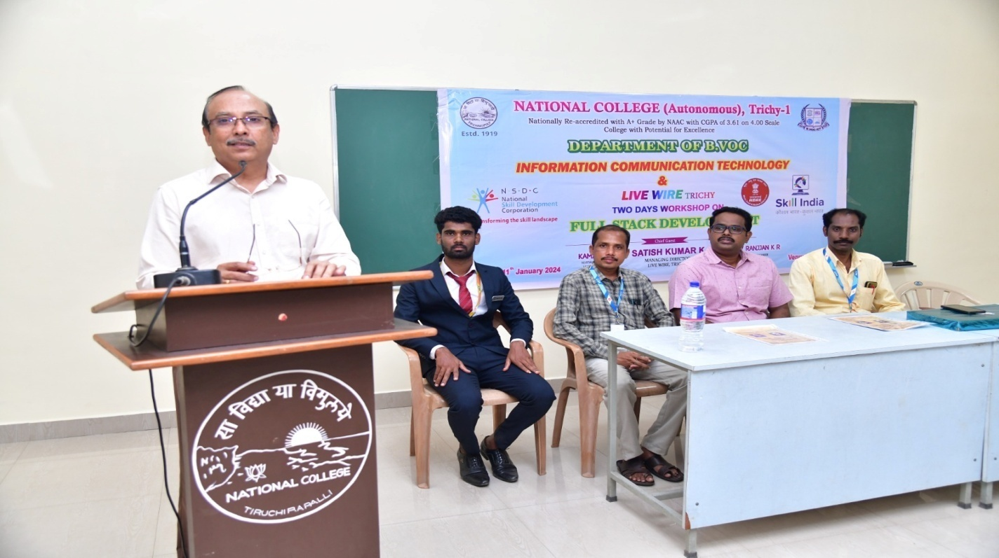

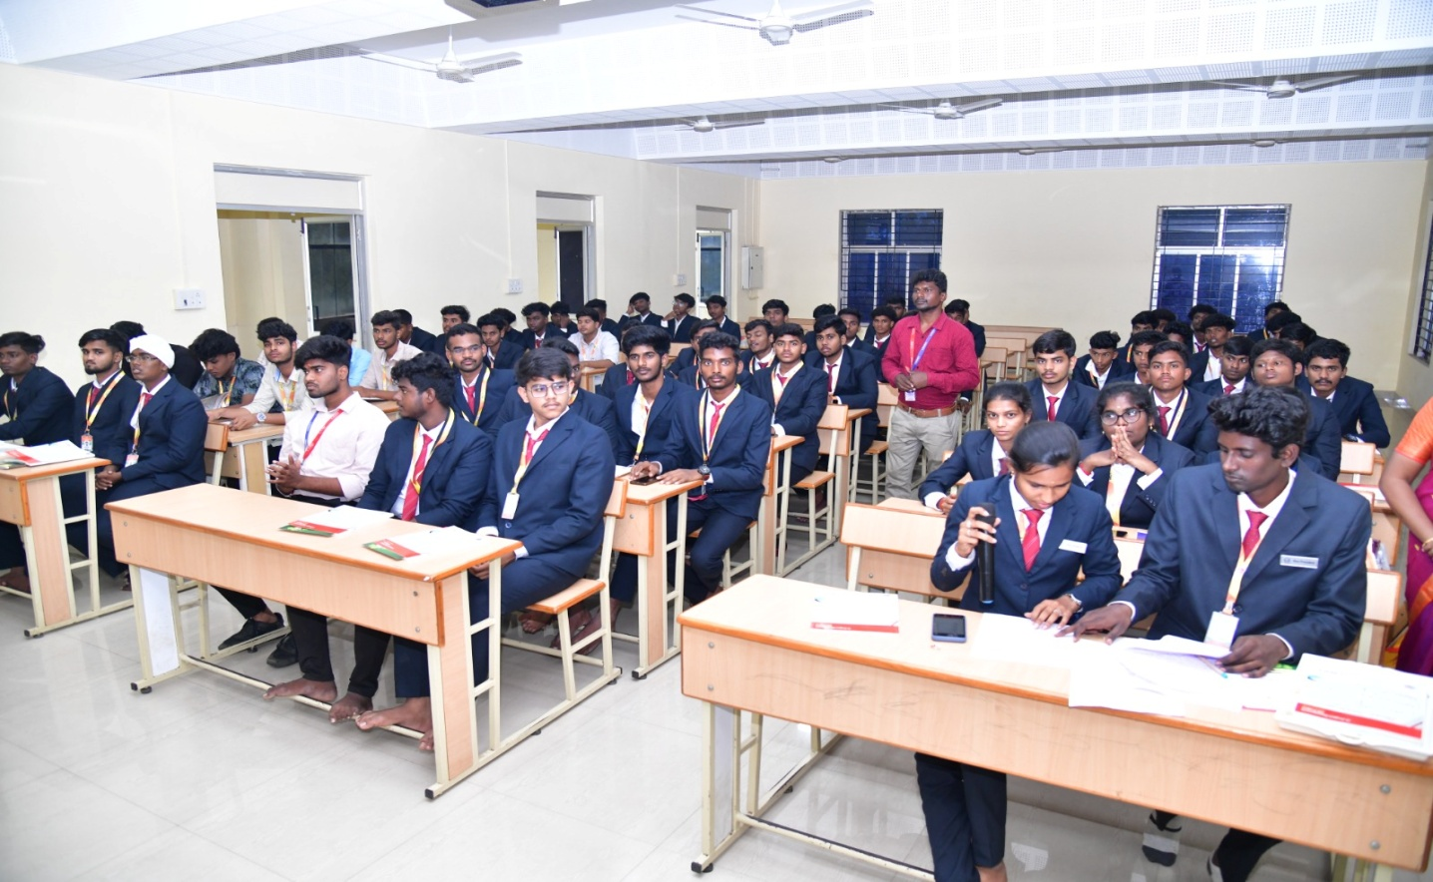

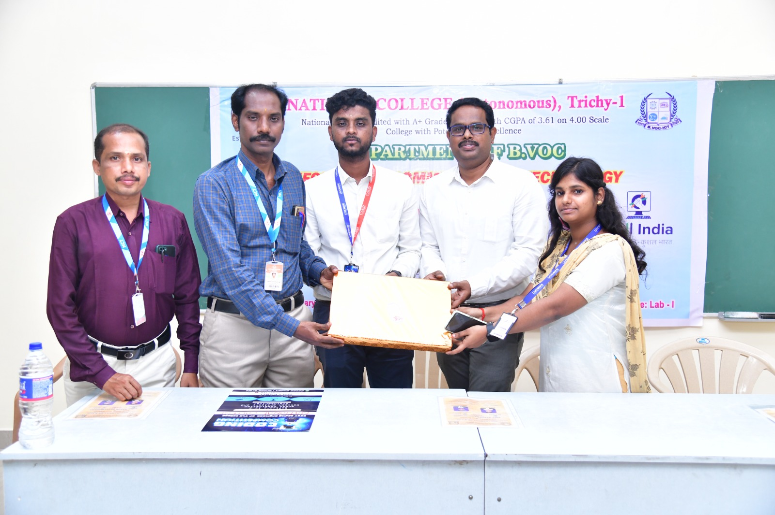

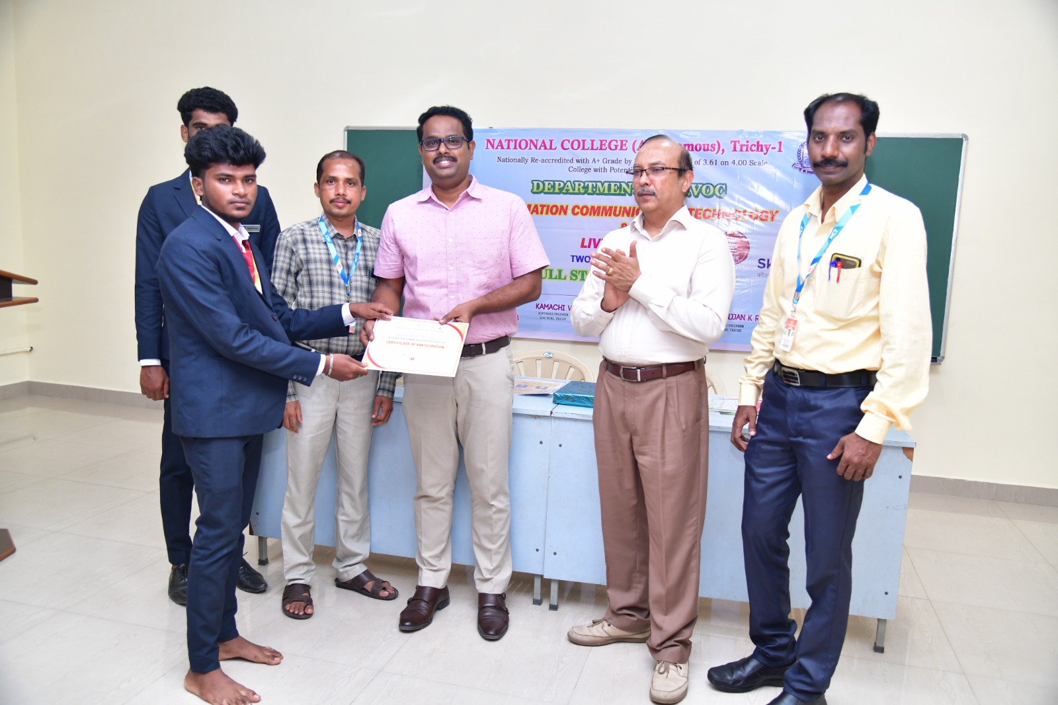

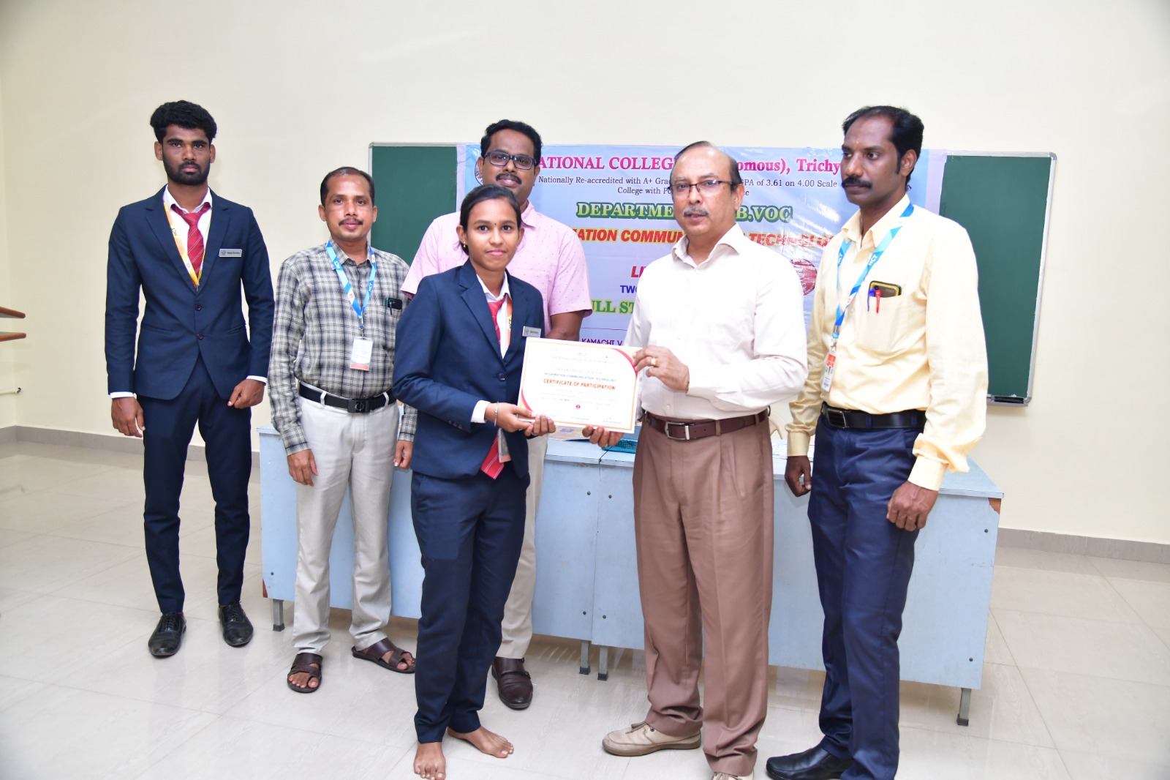

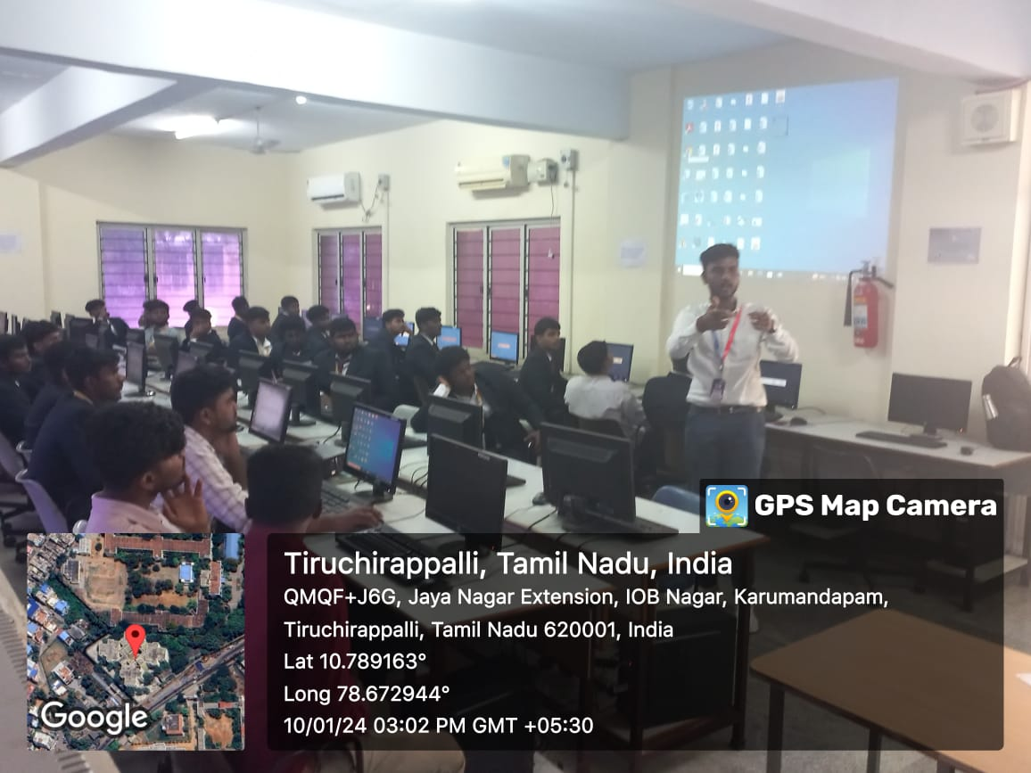

NATIONAL COLLEGE (AUTONOMOUS), TRICHY.
DEPARTMENT OF B.VOC
(INFORMATION COMMUNICATION TECHNOLOGY)
CODING PROGRAM
Trichy National College, Department of B.Voc. (ICT) Computer Lab I, Trichy Live Wire Software Solution, conducted a coding writing competition on 5.1.2024 Friday. The Department of B.Voc. (ICT) had 70 students (I, II, and III years) who participated in the competition. The winners of the two-round competition were felicitated with certificates.
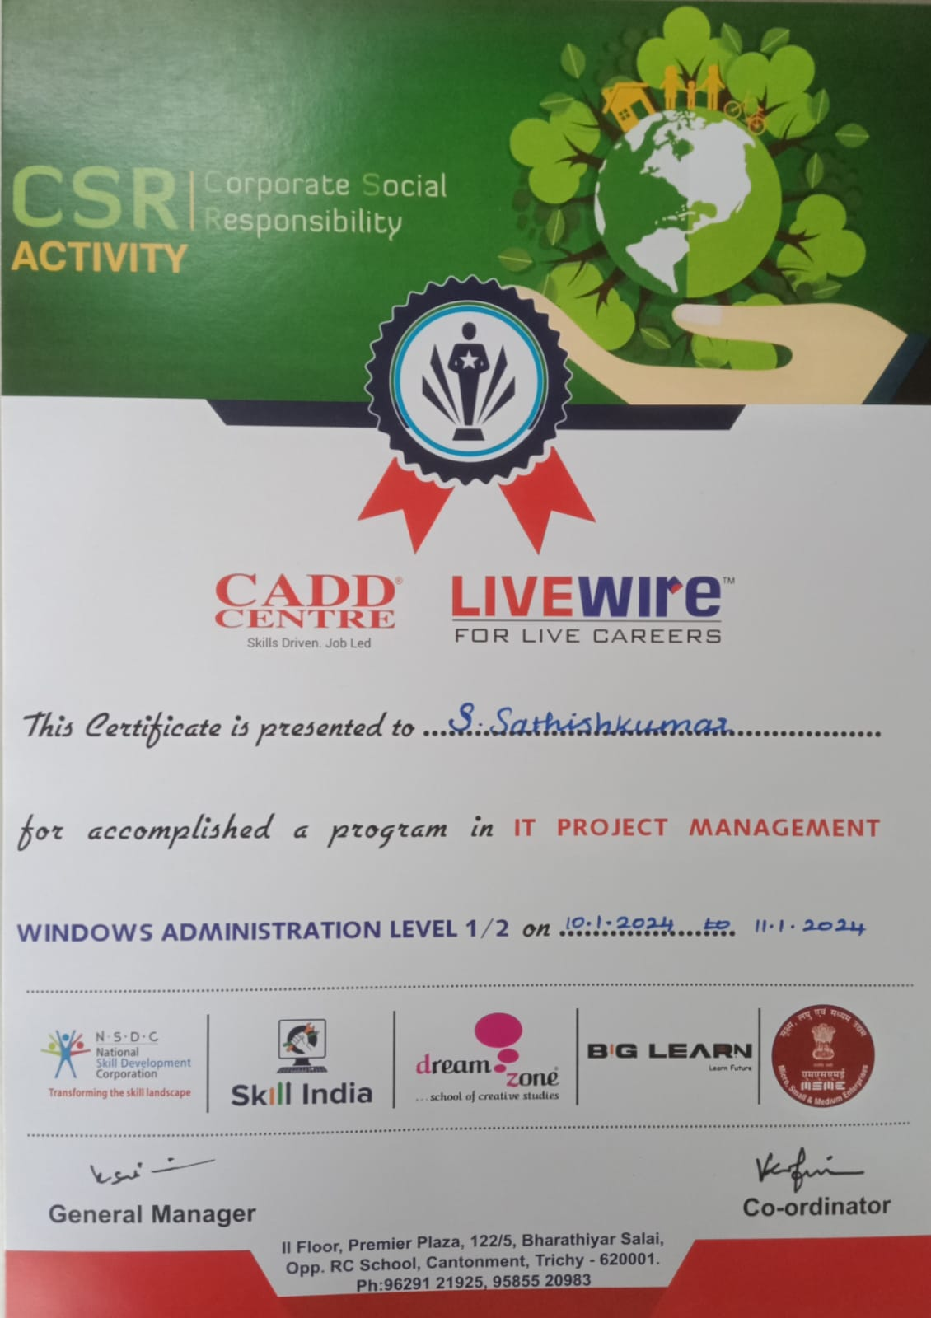

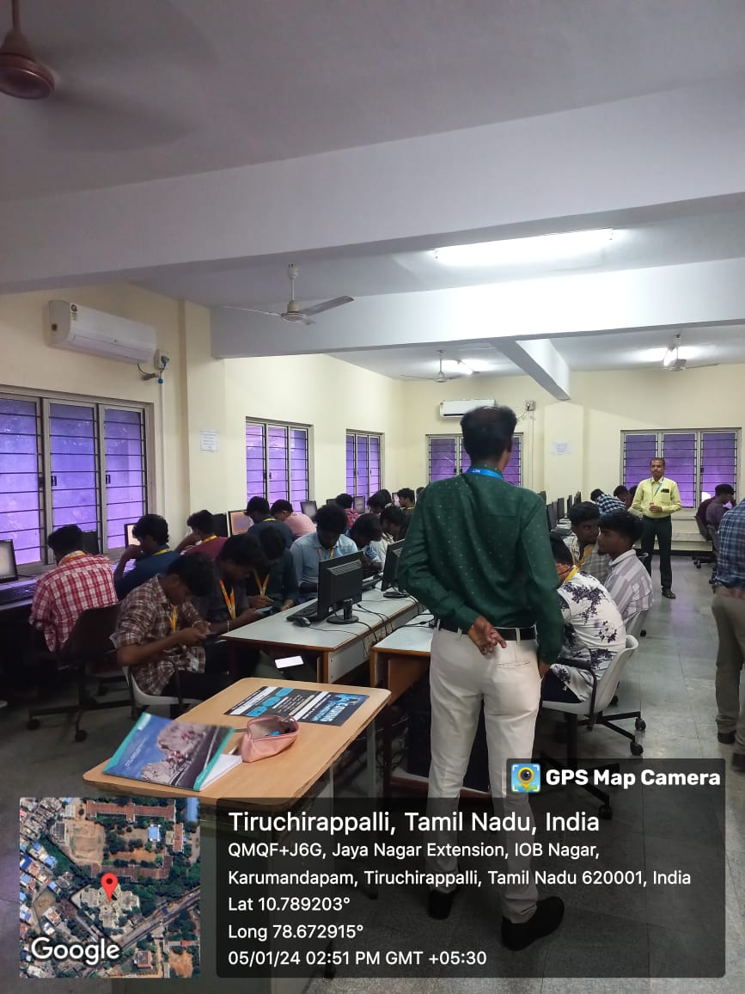

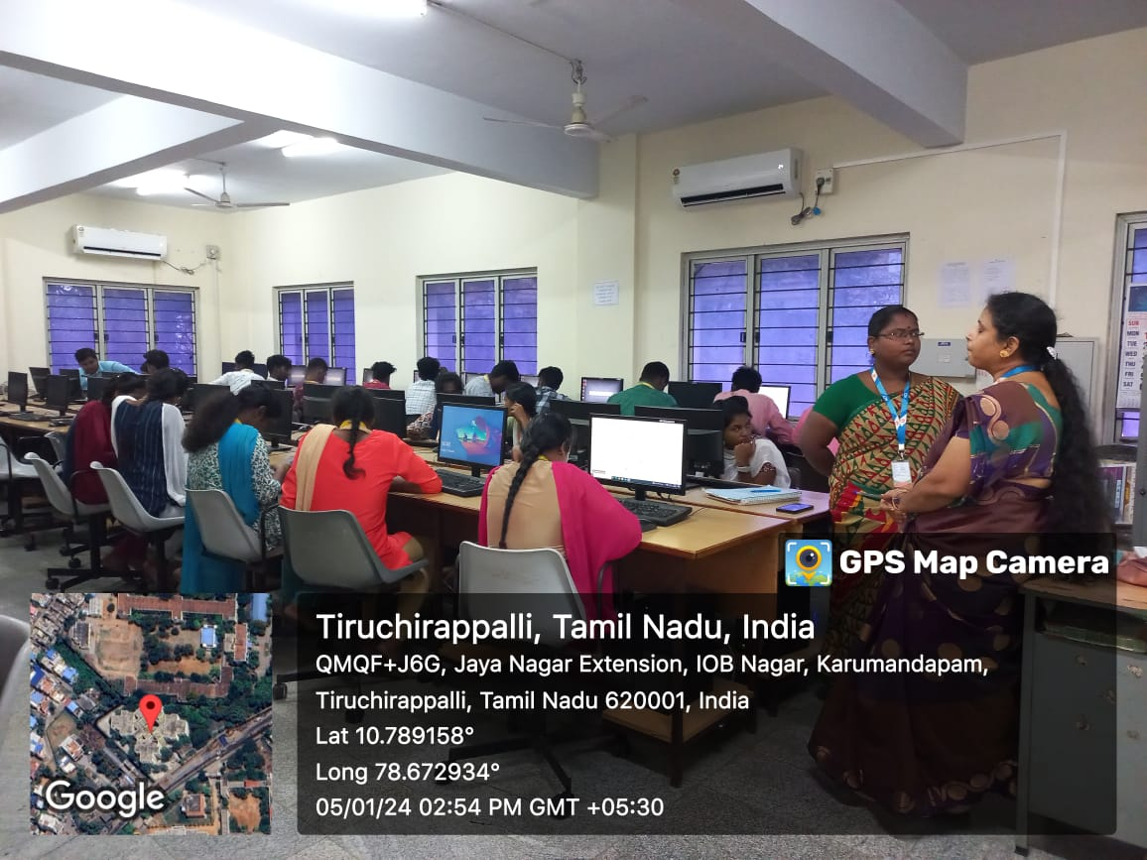

NATIONAL COLLEGE (AUTONOMOUS), TRICHY.
DEPARTMENT OF B.VOC
(INFORMATION COMMUNICATION TECHNOLOGY)
PARENTS TEACHERS MEATING

On January 23, 2024, a Parents Teachers meeting was held in the meeting hall of Trichy National College, organized by the Department of B.Voc(ICT). The meeting was chaired by the Principal of National College, Dr. Kumar. Head of the Department, Parthasarathy, welcomed the parents and discussed the department's development and the students' successes. During the meeting, parents were informed about their children's academic progress and future employment opportunities. Dr. Kumar addressed the parents, emphasizing the importance of their feedback by stating, "You are the mirror we are facing; if there are any deficiencies, tell us and we will correct them.
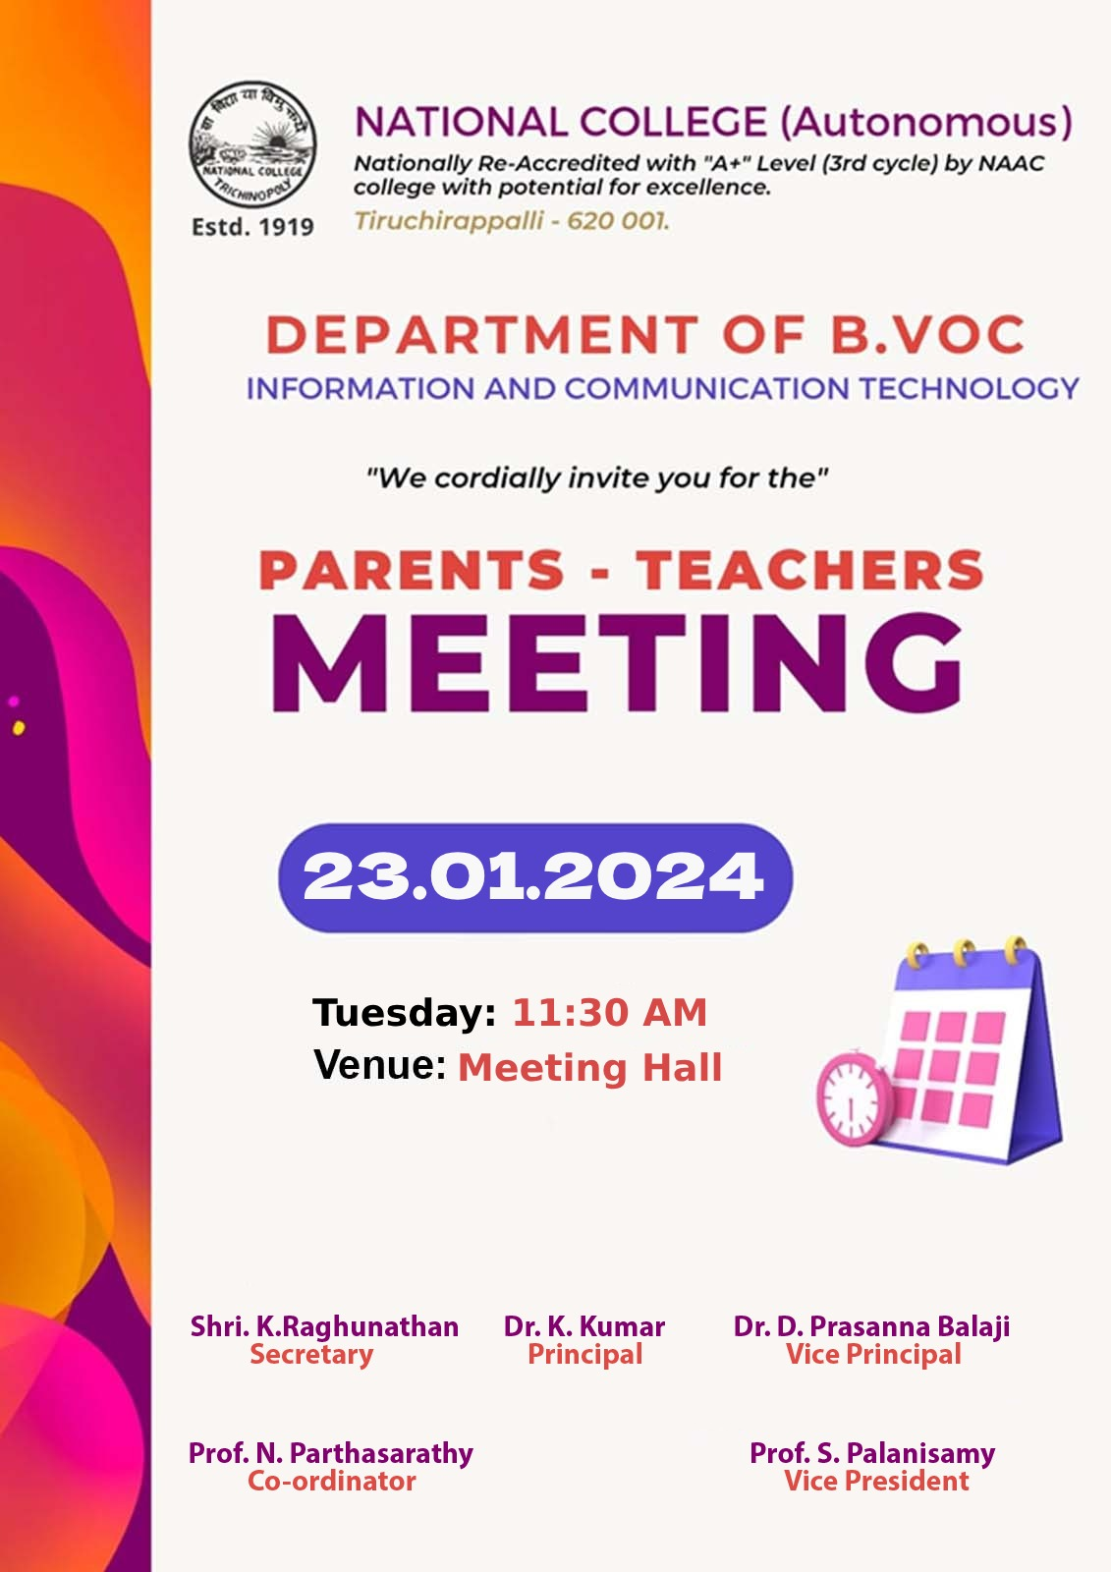
."

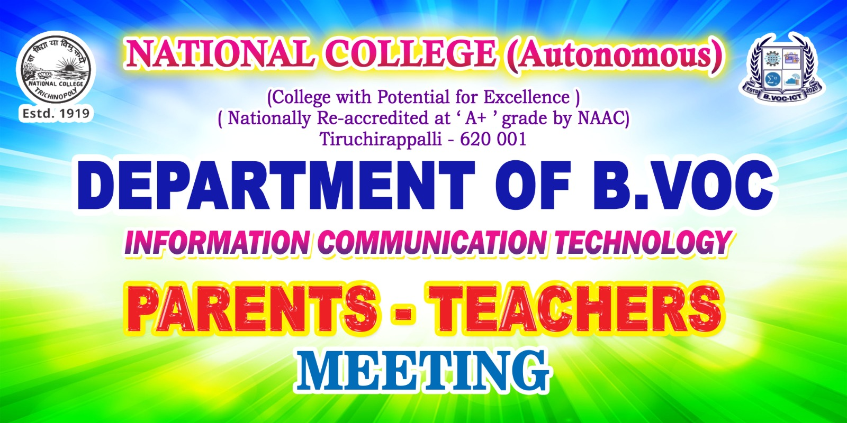

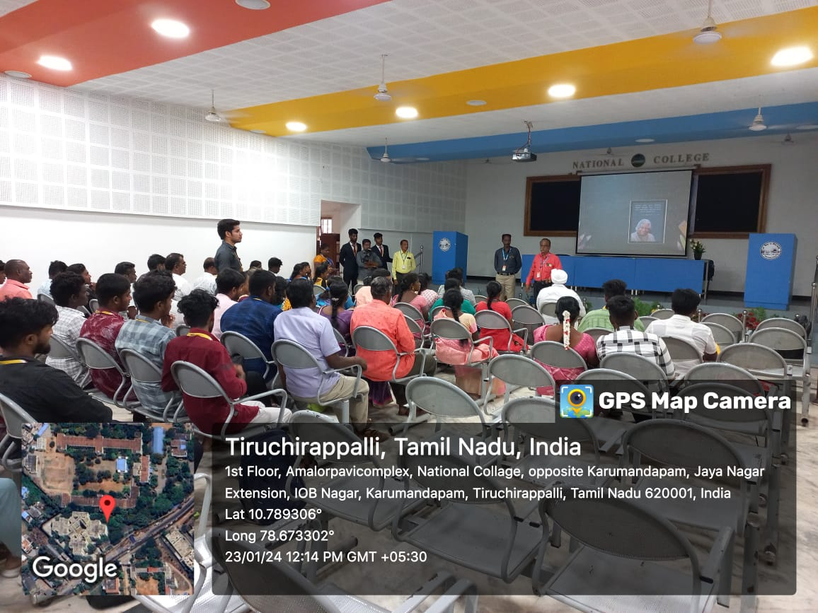

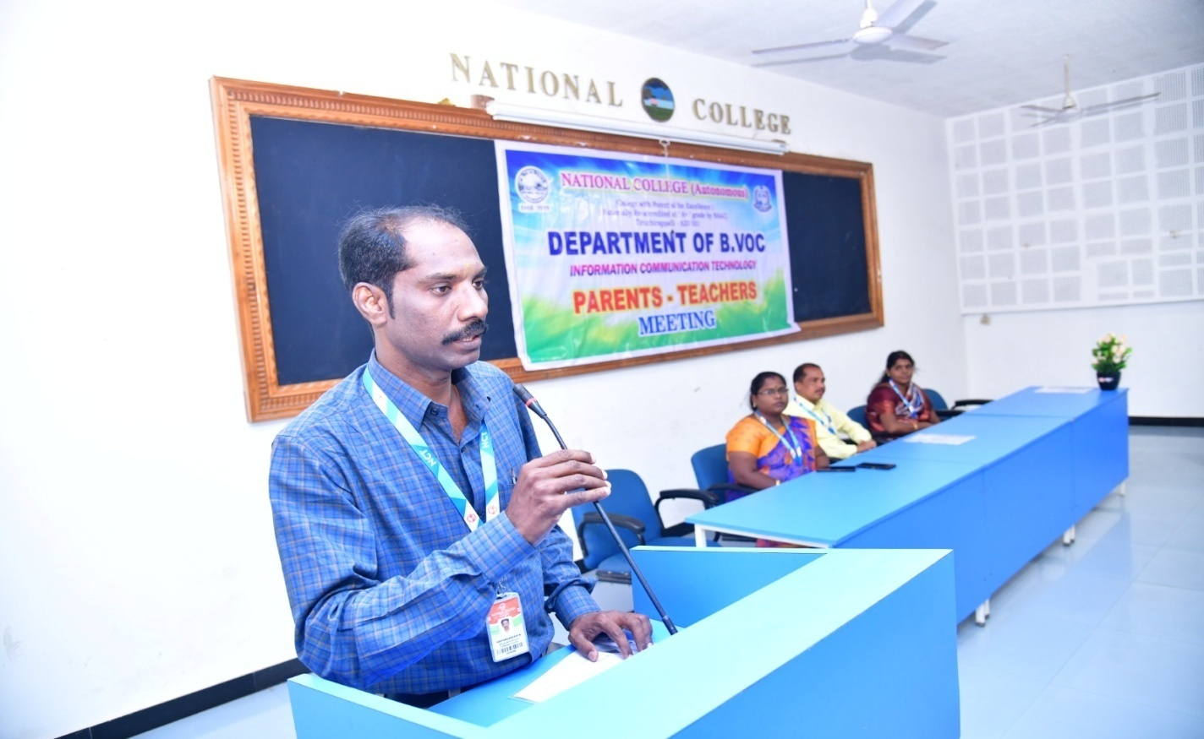

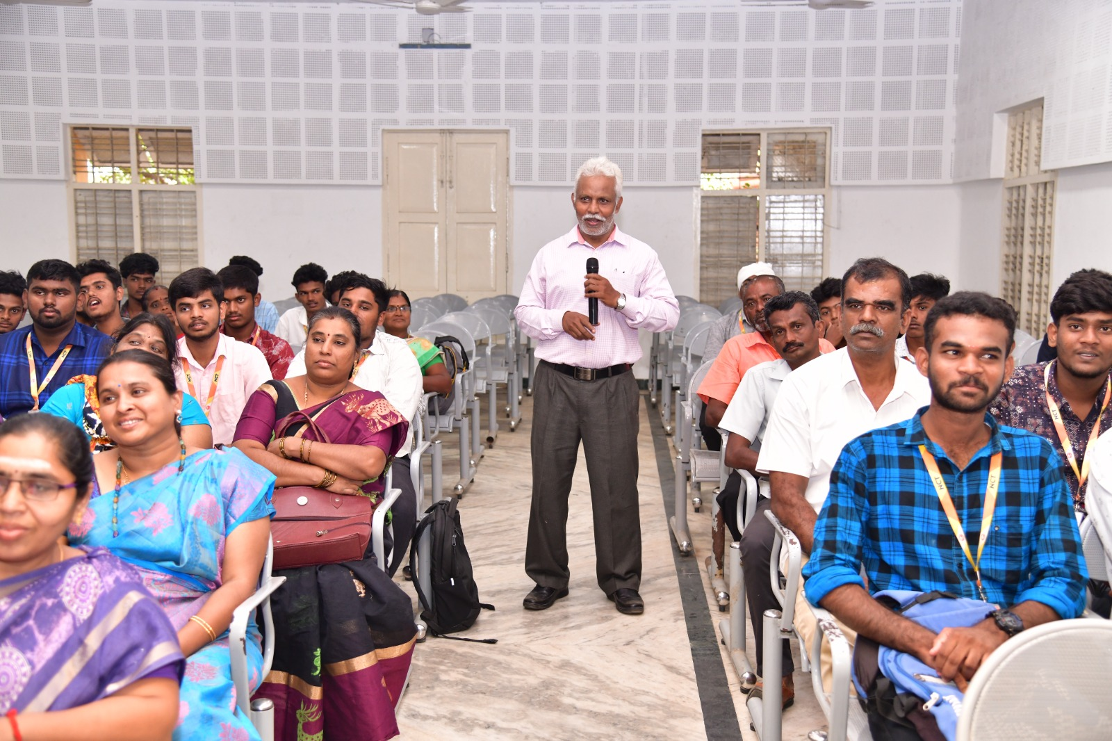

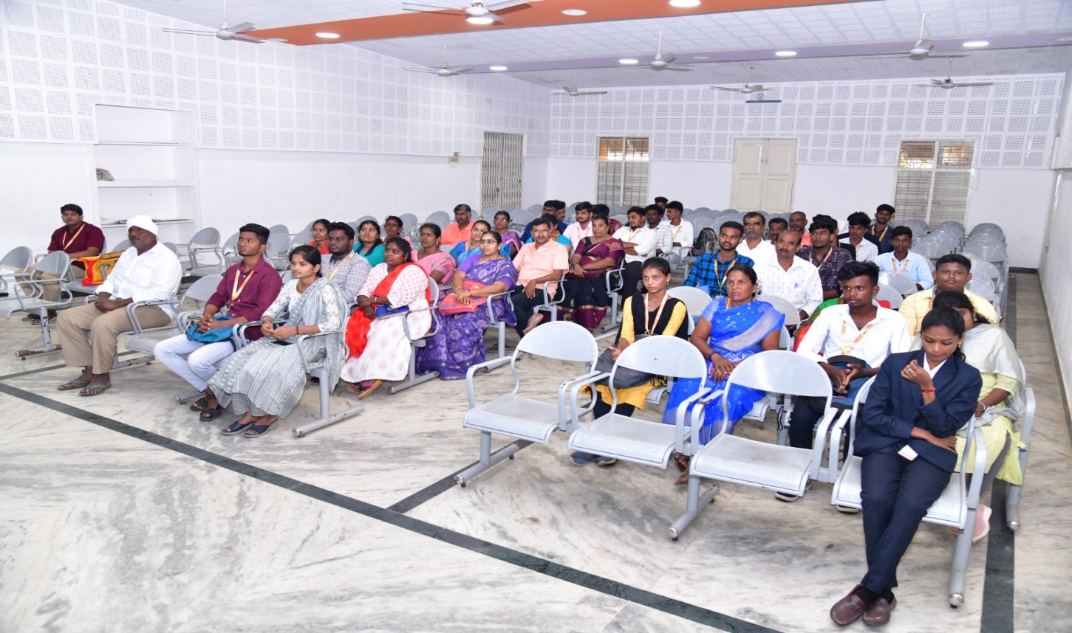

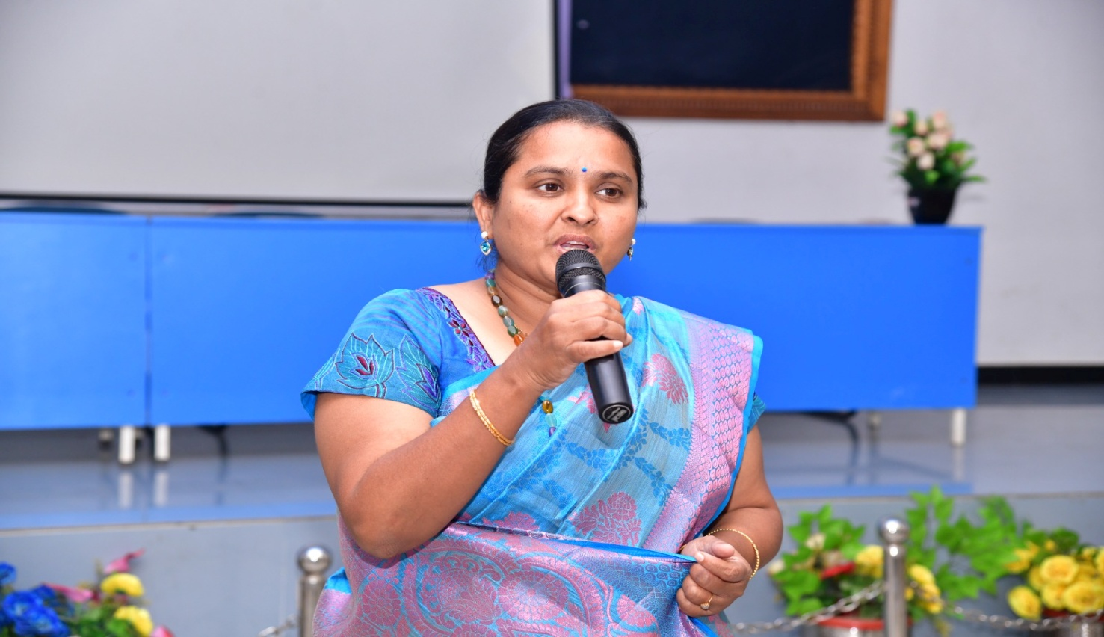

NATIONAL COLLEGE (AUTONOMOUS), TRICHY.
DEPARTMENT OF B.VOC
(INFORMATION COMMUNICATION TECHNOLOGY)
EXTENSION ACTIVITY

Department of B.Voc (ICT) showcased expertise in a seminar at Government Special Higher Secondary School, Mathur, Trichy on 29.01.24(Monday). Students presented on SQL, HTML, Ethical Hacking, and AI tools, with topics ranging from database management to web development and cyber security. The event presided over by Headmaster Vasantha Mallika saw active participation from Department Coordinator N.Parthasarathy and Assistant Professor S.Palanisamy. This initiative exemplifies the college's commitment to practical education and collaboration with local institutions, fostering a dynamic learning environment for aspiring ICT professionals.
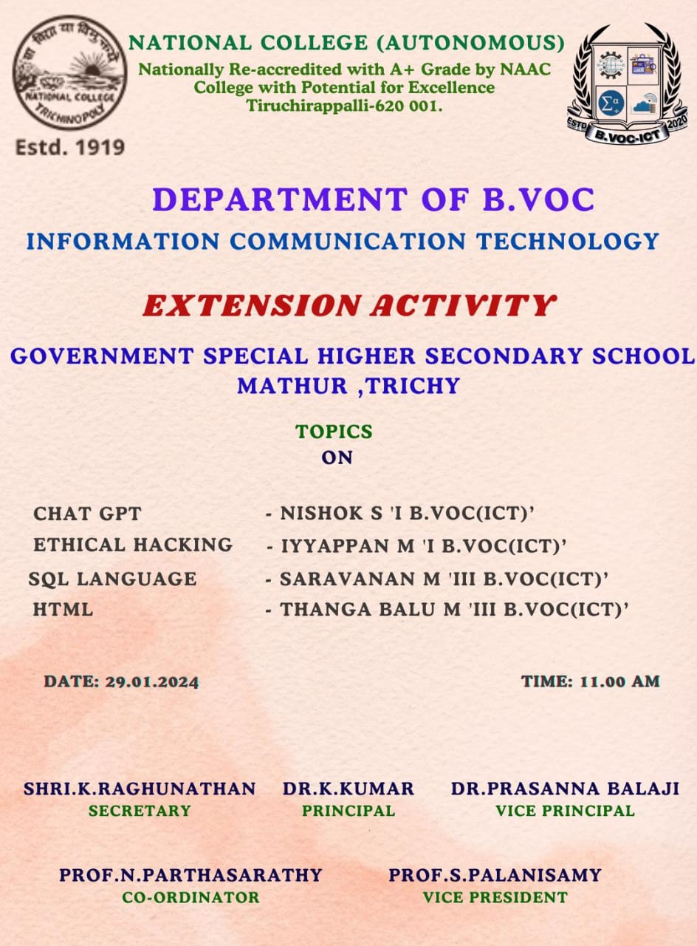

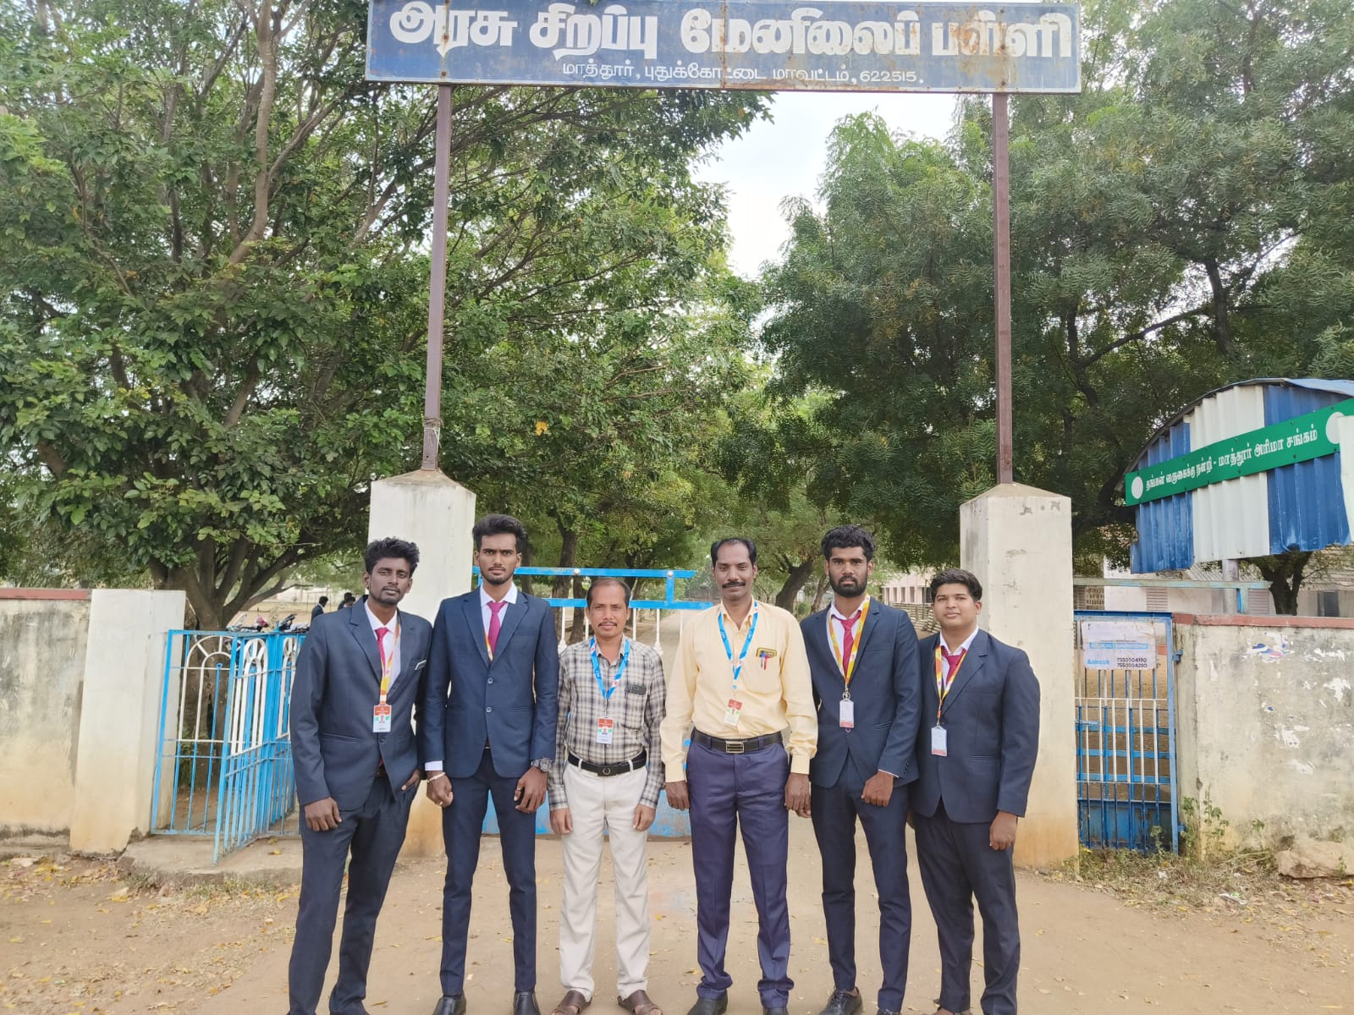

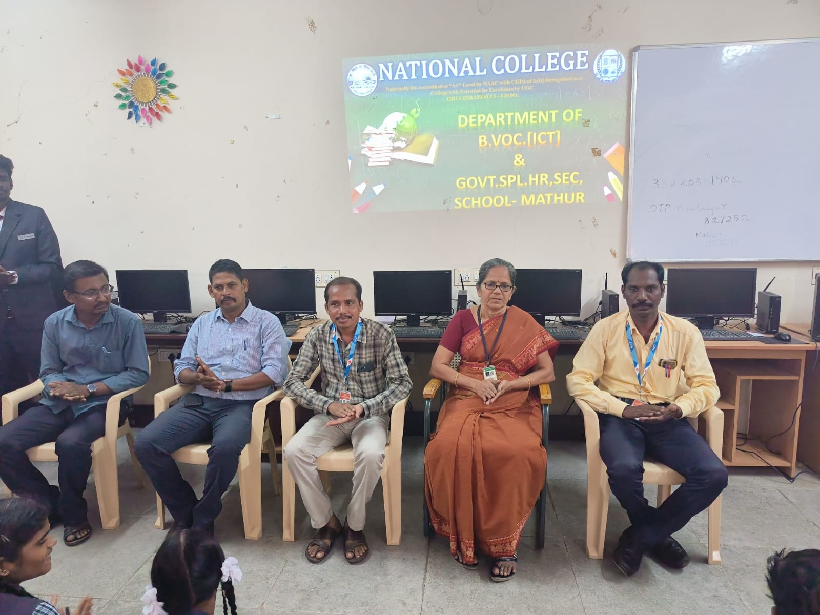

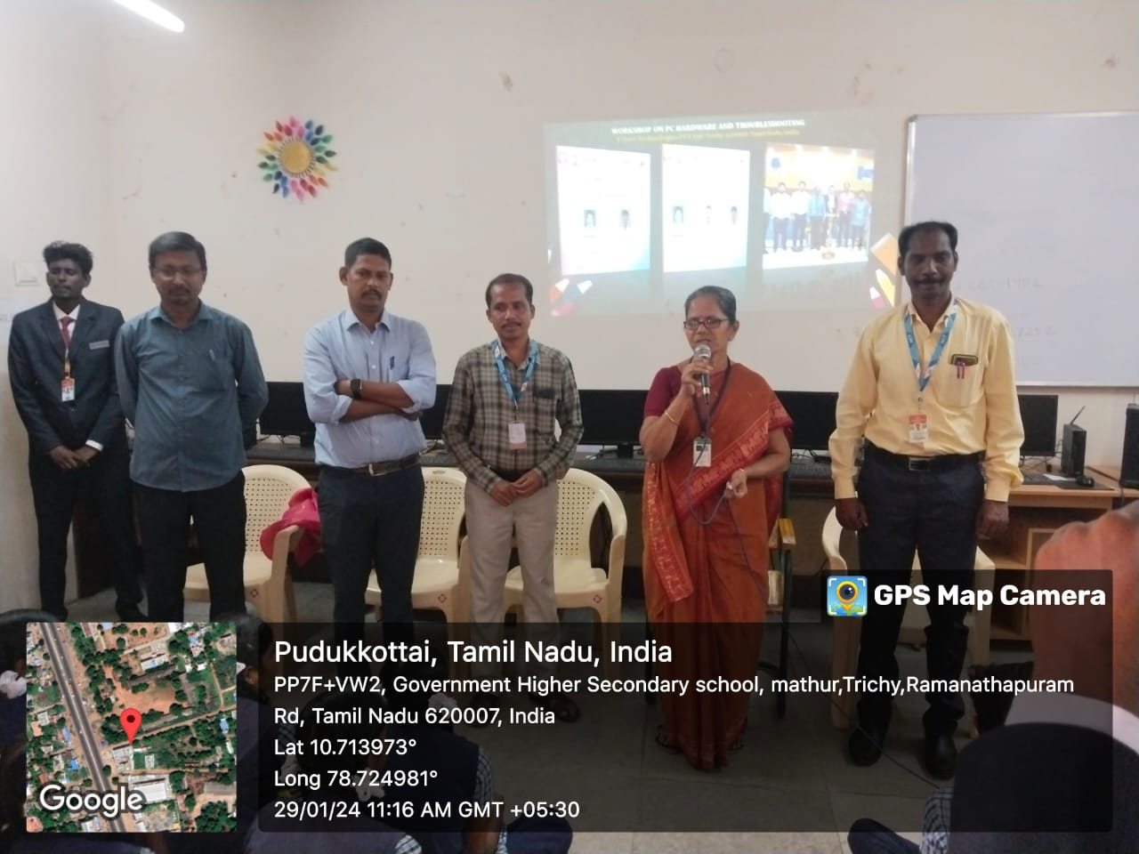

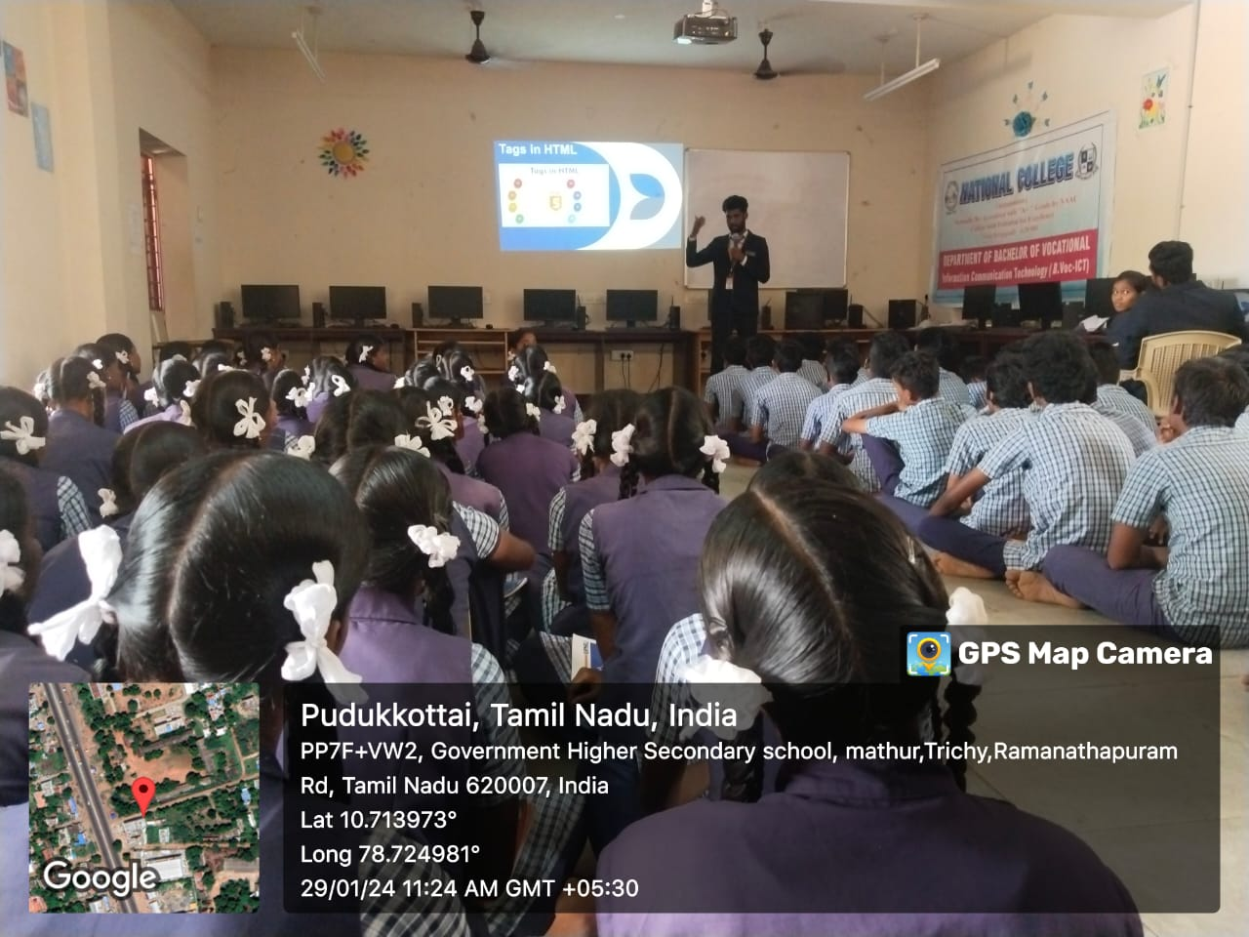

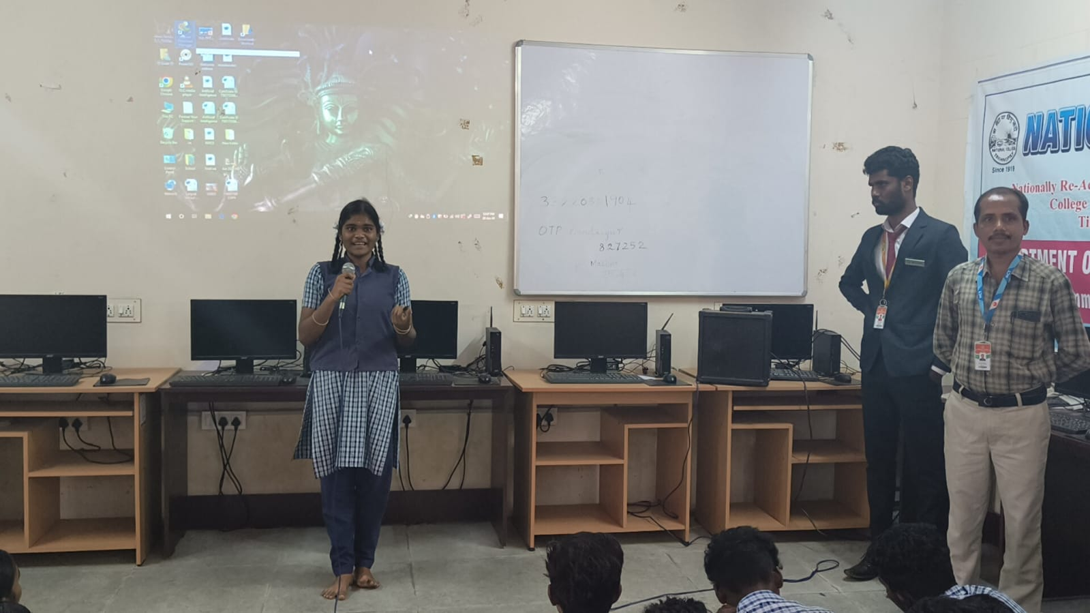

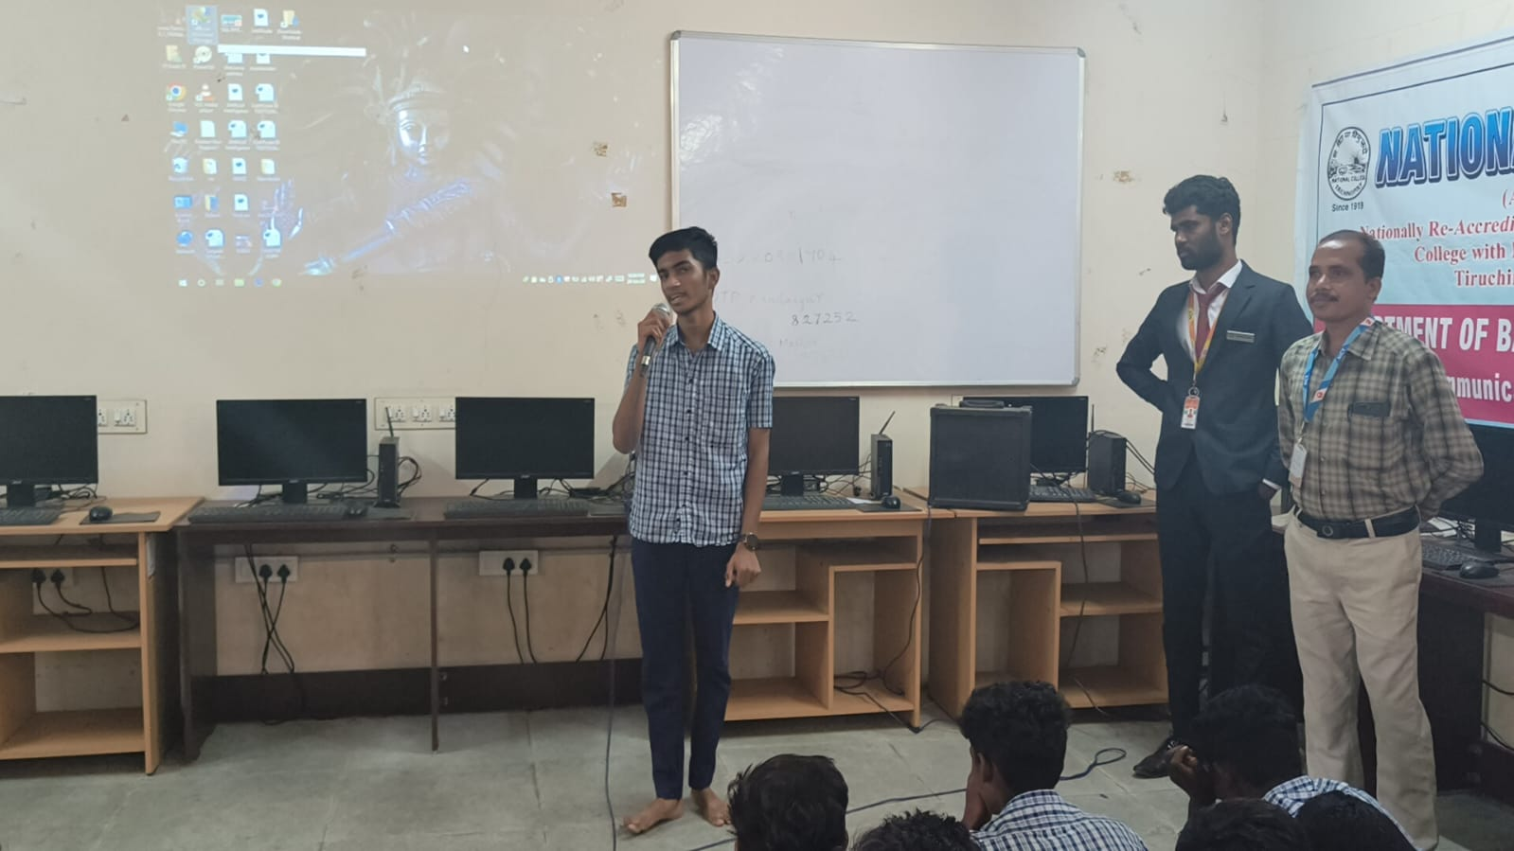

NATIONAL COLLEGE (AUTONOMOUS), TRICHY.
DEPARTMENT OF B.VOC
(INFORMATION COMMUNICATION TECHNOLOGY)
SEMINAR
On Thursday, February 15, 2024, a seminar on "UI UX Design and Testing" was held at 4:00 PM in the College Library AV Hall, organized by the Department of B.Voc (ICT) at National College, Trichy. The event was presided over by Dr. K. Kumar. The ceremony began with a welcome address by student Ayyappan. The special guest for the seminar was Ismail, Managing Director of T4TEQ Software Solution, Trichy. He started the seminar by asking the students, "What is UI UX?" and encouraged them by stating that UI UX design is simpler than other programs and offers better employability opportunities. Following his presentation, Ismail answered various questions from the students. The Head of the B.Voc (ICT) Department, N. Parthasarathy, honored the special guest with a memento. The program concluded with a vote of thanks by student Abdul Sameer, and the event ended on a positive note.
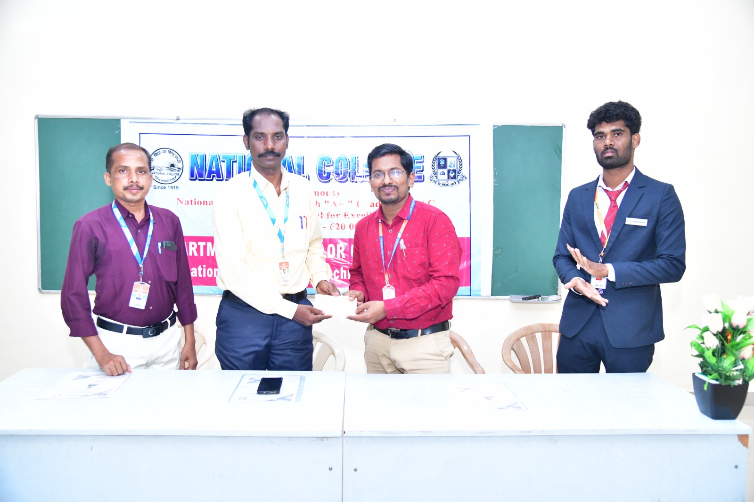

PHOTO DETAILS:
Crawl from left
1. Prof. S. Palanisamy, Vice President, B.VOC. (ICT), National College, Trichy.
2. Prof. N. Parthasarathy, Coordinator & Head, B.VOC.(ICT), National College, Trichy.
3. Mr. N. S. Ishmail, Managing Director, T4TEQ Software Solution, Trichy.
4. Student’s Vice President, Thangabalu (III B.VOC)

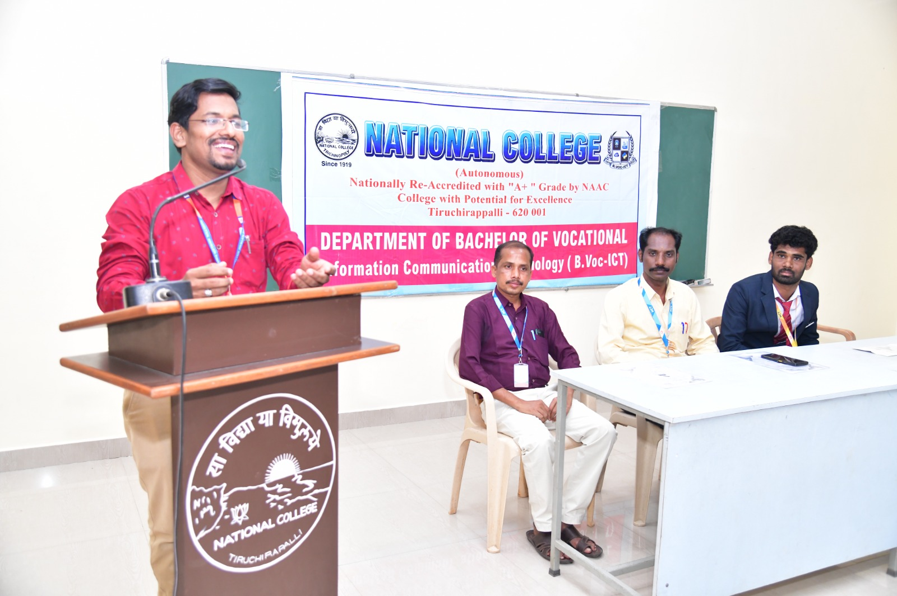

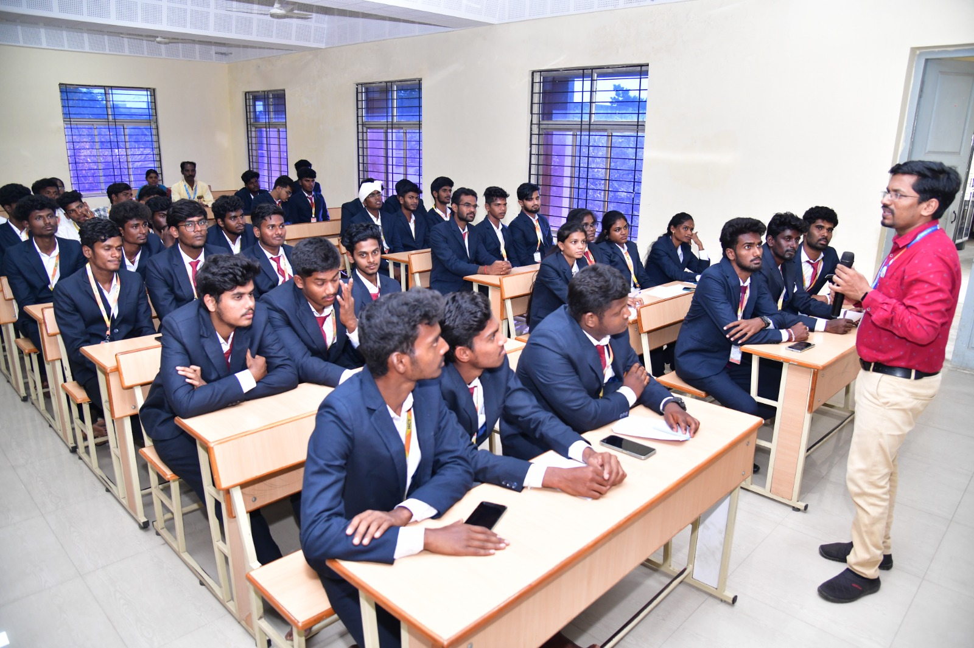
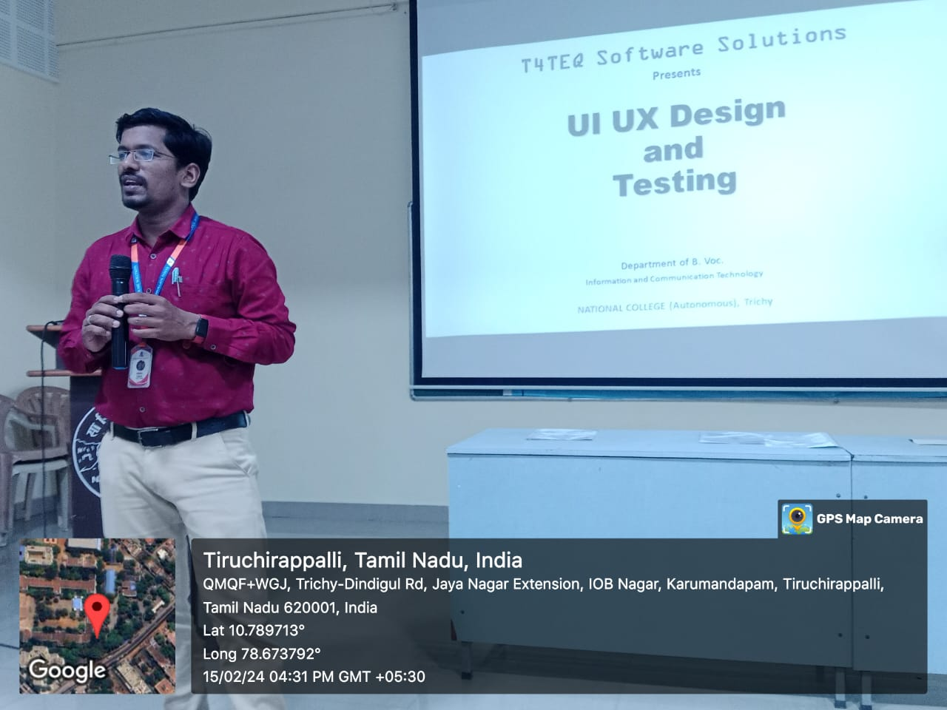

NATIONAL COLLEGE (AUTONOMOUS), TRICHY.
DEPARTMENT OF B.VOC
(INFORMATION COMMUNICATION TECHNOLOGY)
MoU
On February 27, 2024, the Department of B.Voc (ICT) at Trichy National College and Svasti Technology Solutions signed a Memorandum of Understanding (MoU) at the Trichy National College Meeting Hall. The ceremony was presided over by Principal Dr. K. Kumar and coordinated by Prof. N. Parthasarathy, Head of the Department of B.Voc (ICT). Student Ayyappan delivered a warm welcome address to commence the event. The MoU aimed at advancing emerging software technologies, highlighting their significance in the industry. Mr. A. Kesavan and Mr. Nitheeswaran, both software developers, represented Svasti Technology Solutions and attended the ceremony to sign the agreement. The Principal of National College honored the special guests, recognizing their contribution and support. The program concluded with student Abdul Sameer expressing gratitude with a vote of thanks, bringing the
event to a successful close.
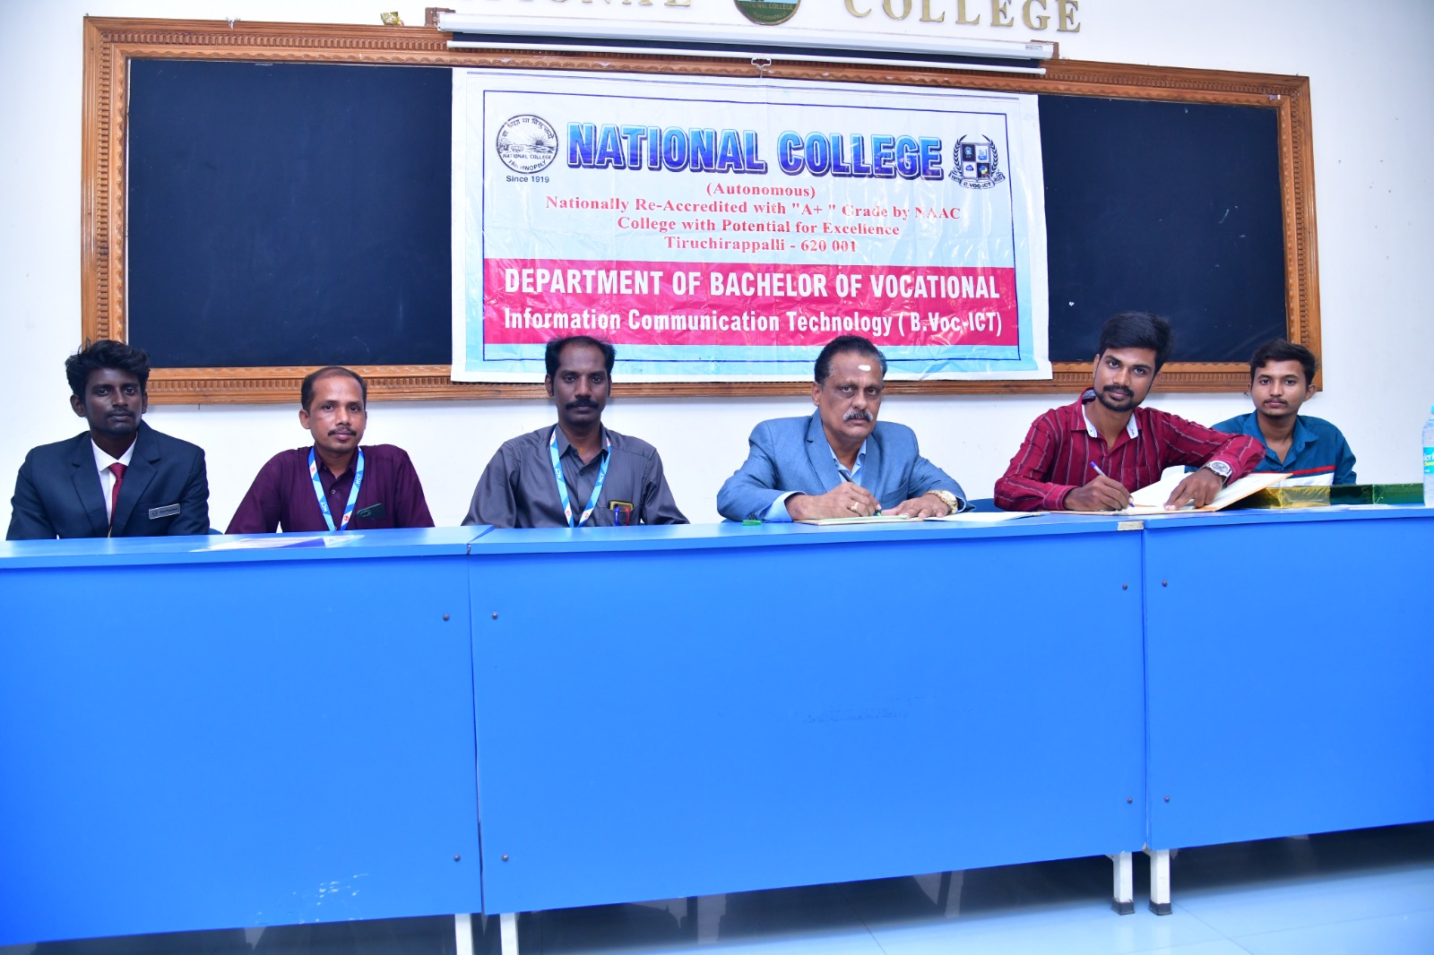
PHOTO DETAILS:
Crawl from left
1. M. Iyappan Students Vice President B.VOC (ICT) National College, Trichy.
2. Prof. S.Palanisamy Vice President, B.VOC (ICT) National College, Trichy.
3. Prof. N. Parthasarathy HOD, B.VOC (ICT) National College, Trichy.
4. Dr.Kumar Principal, National College, Trichy.
5. Mr. A. Kesavan Managing Director, Svasti Technology Solutions, Trichy.
6. Mr. Nitheeswaran Program Developer, Svasti Technology Solutions, Trichy.

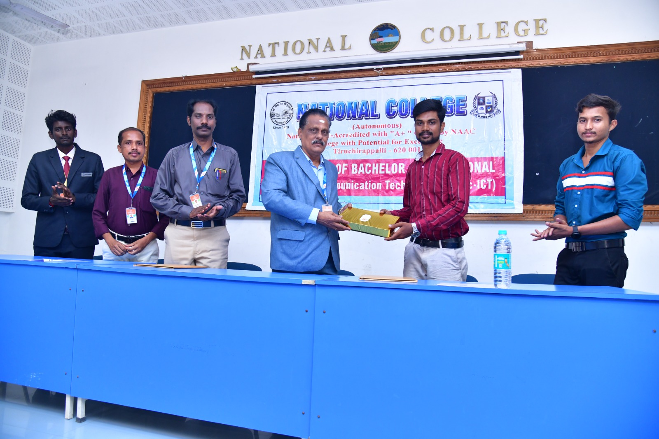

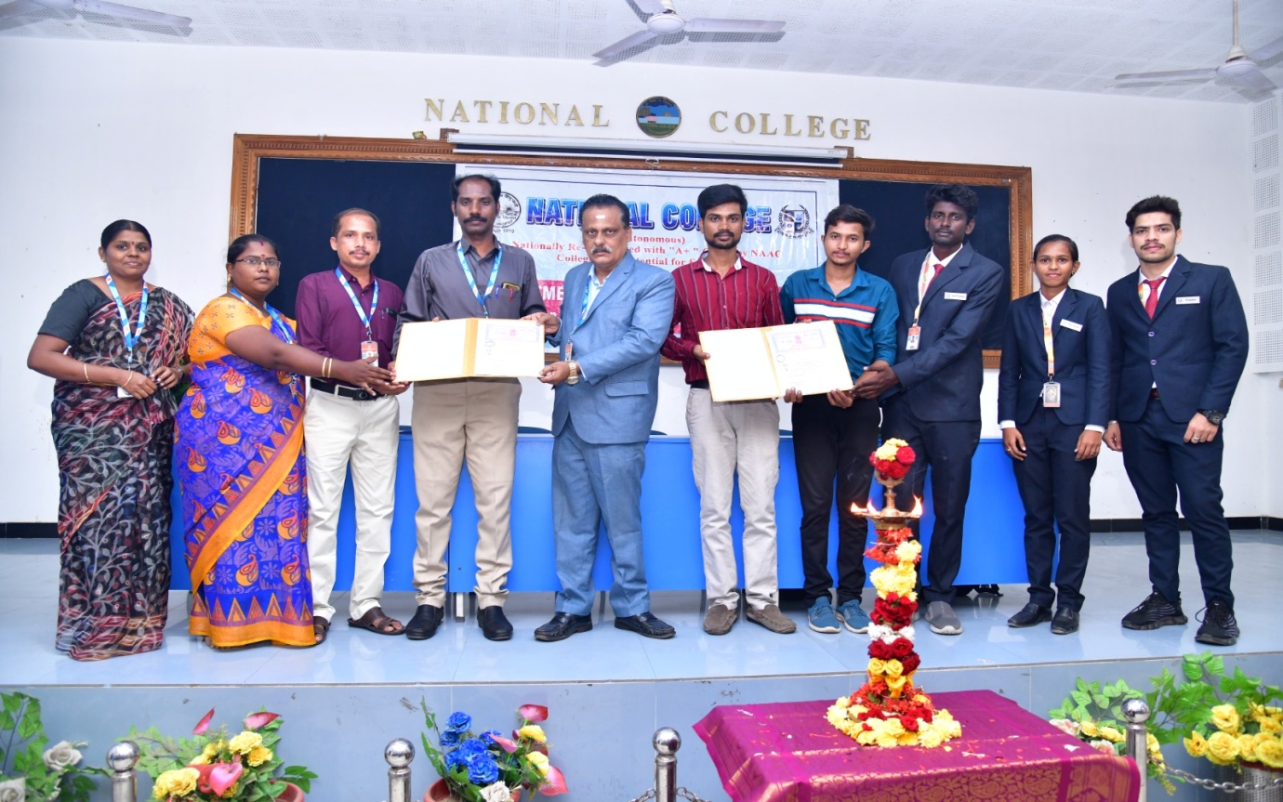

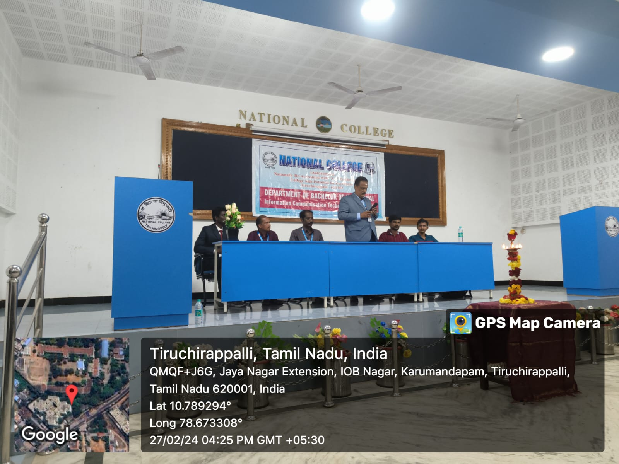

NATIONAL COLLEGE (AUTONOMOUS), TRICHY.
DEPARTMENT OF B.VOC
(INFORMATION COMMUNICATION TECHNOLOGY)
MoU
On February 29(Thursday), 2024 the Trichy National College Department of B.Voc (ICT) and FG Global Training (P) Ltd (DSI Technology Solutions) Trichy signed an MoU at the Trichy National College Meeting Hall. The ceremony was presided over by Principal Dr. K. Kumar, and the event was coordinated by Prof. N. Parthasarathy, head, department of B.Voc (ICT). The student, Swathi, delivered a warm welcome address. The MoU focused on the development of emerging software technology, emphasising its importance in the industry. Mr. V. Suresh and Ms.M.Pandi Selvi represented FG Global Training (P) Ltd Software Company and attended the ceremony to sign the agreement. The National College Principal felicitated special guests, acknowledging their presence and support. The programme concluded with student Abdul Sameer expressing gratitude through a vote of tthanks.
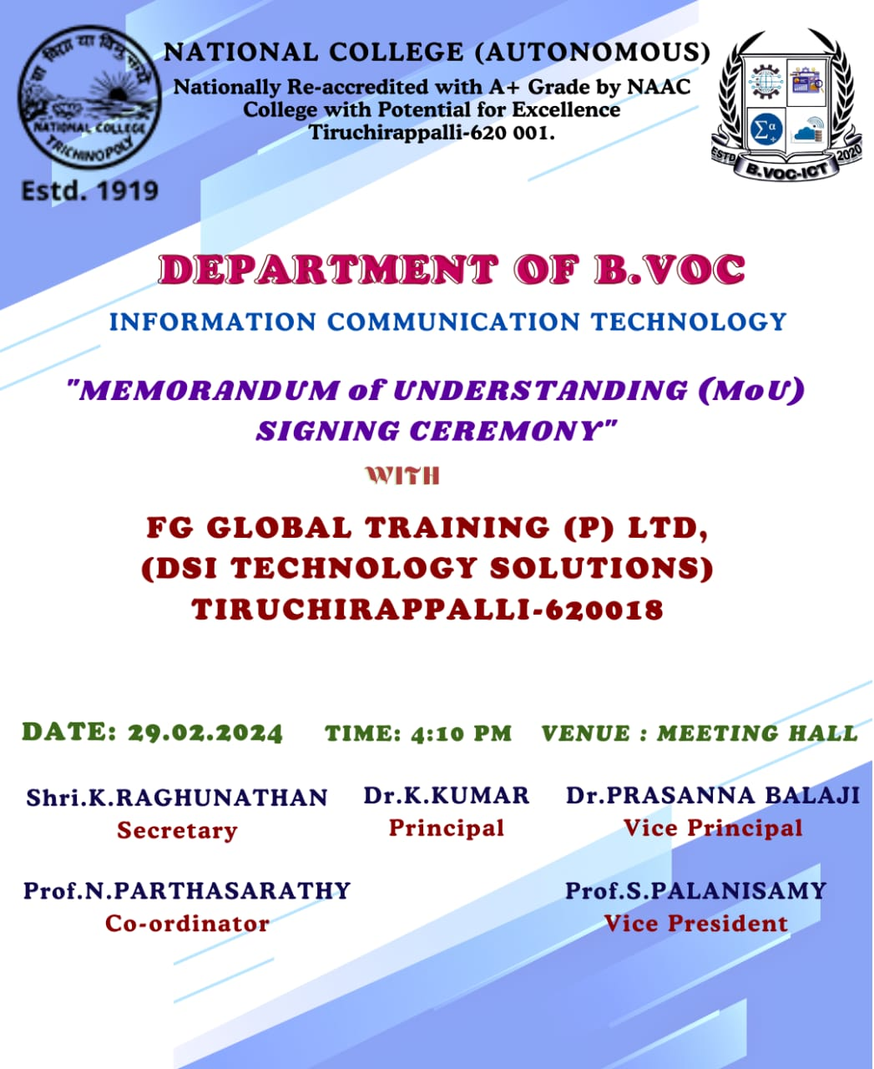

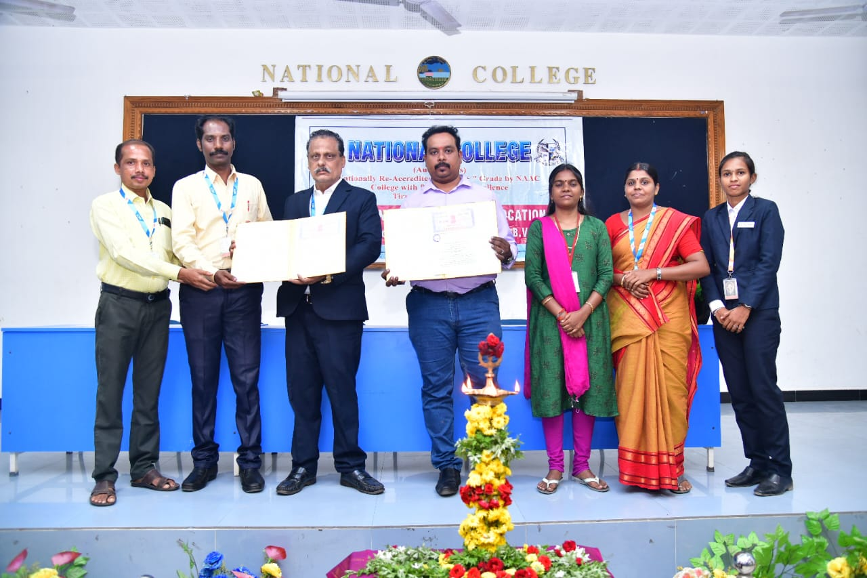

PHOTO DETAILS:
Crawl from left

- Prof. S. Palanisamy, Vice President, B.VOC (ICT), National College, Trichy.
- Prof. N. Parthasarathy, HOD, B.VOC (ICT), National College, Trichy.
- Dr. K. Kumar, Principal, National College, Trichy.
- Mr. V. Suresh, Managing Director, FG Global Training (P) Ltd. (DSI Technology Solutions), Trichy.
- Ms. M. Pandi Selvi, software developer at FG Global Training (P) Ltd. (DSI Technology Solutions), Trichy.
- Ms. C. Usha, Assistant Professor, B.VOC (ICT), National College, Trichy.
- M. Swathi, Student's President, B.VOC (ICT), National College, Trichy

